***Introduction to Docker, Kubernates and Openshift***

* *Kubernetes is an open source platform for orchestrating running containers was developed and contributed to the open source community by Google in 2015.*

***Introduction to Containers:***

* *A container is an executable unit of software in which application is packaged along with its libraries and dependencies, in common ways so that it can be run anywhere whether on a desktop, on-premises, or in the cloud.*
* *To do this, containers take advantage of a form of operating system virtualization in which features of the operating system are leveraged to both isolate processes and control the amount of CPU, memory and disk storage that those processes have access to.*
* *In the case of Linux kernel, namespaces and cgroups are the operating system primitives that enable this virtualization.*
* *Containers are small, fast and portable because unlike a virtual machine, they do not need to include a guest operating system in every instance and can simply leverage the features and resources of the host operating system instead.*
* *Containers first appeared decades ago, but the modern container era began in 2013 with the introduction of Docker.*
* *The containers are standardization for how we package and ship software. All the dependencies needed to run an application are packaged with it making it easy to move it around and run it in variety of locations.*
* *Just as you can ship anything that fits in the container, modern platforms for running containers can run anything as long as it can be packaged as a container. This portability is incredibly useful in software development.*
* *The primary advantage of containers, especially compared to virtual machine, is the level of abstraction they provide that makes them lightweight and portable.*
* *Containers are lightweight.* ***They share the machine operating system kernel****, eliminating the need for a full operating system instance per application.*
* *This makes the container files small and less taxing on resources. Their smaller size, especially compared to virtual machines means they can spin up quickly.*
* *They are better able to support cloud-native applications that scale horizontally.*
* *Containers carry all their dependencies with them, meaning that the software can be written once and then run without needing them to be re-configured across laptops, cloud and on-premises computing environments.*
* *This portability also provides consistency in your environment so that you don’t have to worry about differing dependencies installed in different environments.*
* *The combination of their deployment portability and consistency across platforms and their small size make containers an ideal fit for modern development and application patterns which expect regular deployments of incremental changes.*
* *Like virtual machines before them, containers enable developers and operators to improve the CPU and memory utilization of physical machines.*
* *Containers go even more further because they also enable a microservice architecture which means that the application components can be deployed and scaled more granularly.*
* *This granularity provides an attractive alternative to having to scale up an entire monolithic application when, for example, a single component is struggling with load.*

***Containers vs Virtual Machines:***

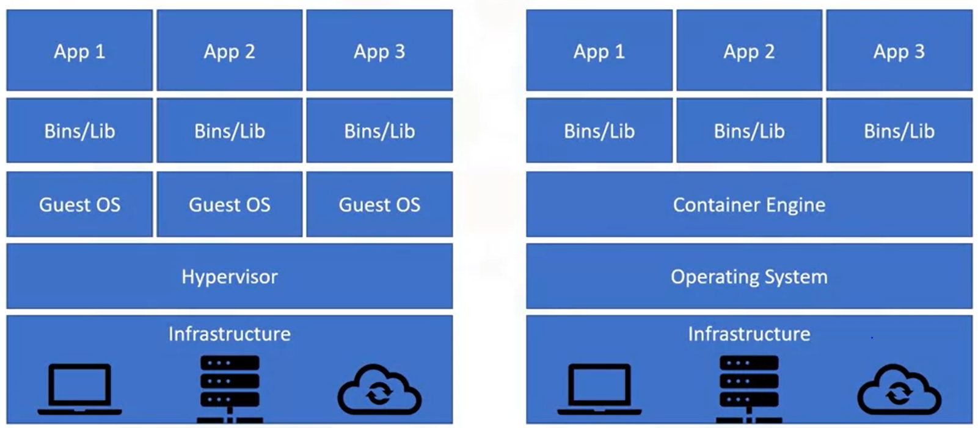

***Virtual Machines:***

* *Virtual machines provide a useful comparison with containers and help us understand the appeal of containerization.*
* *With Virtual machines, a hypervisor runs on the top of your infrastructure. This Hypervisor is responsible for creating virtual machines.*
* *It treats resources such as CPU and memory as a pool that can be utilized by the various virtual machines running on the hardware.*
* *In this model, the hardware is virtualized so that multiple machines with potentially different operating systems can run on the same physical hardware.*
* *As shown above, each virtual machine has its own operating system. In addition, binaries and libraries are present in the virtual machine, which enables the execution of the applications.*

***Containers:***

* *With Containers, you still have the physical infrastructure at the bottom of the stack.*
* *But instead of placing a hypervisor as the next layer to virtualize the hardware you have an operating system.*
* *Above that is the container engine, which, like a hypervisor with virtual machines is responsible for running containers.*
* *In this way, containers virtualize the operating system rather than the infrastructure.*
* *This enables the infrastructure to have a single copy of the operating system which saves a lot of space.*
* *The binaries, libraries and applications run on the container engine.*
* *The clear benefit of the containers is that you do not have to run a dedicated operating system instance for each virtual environment.*
* *Instead, one operating system is virtualized across all the containers. This enables containers to be much more lightweight than the virtual machines.*
* *While virtual machines can take several seconds or minutes to startup and can be many gigabytes in size, containers can be only a few megabytes and start in mere seconds.*
* *Containers are becoming increasingly prominent, especially in cloud environments.*

***UseCases for Constructors:***

* *Containers are small and lightweight, which makes them a good match for microservices architecture where applications are constructed of many loosely coupled and independently deployable.*
* *The combination of microservices architecture and containers is a common foundation for many teams that embrace DevOps as the way they build, ship and run software.*
* *Because containers can run consistently anywhere, across laptop, on-premises and cloud environments they are ideal underlying architecture for hybrid cloud and multi-cloud scenarios where organizations find themselves operating across a mix of multiple public clouds in combination with their data centers.*
* *Finally, one of the most common approaches to modernizing applications is to begin by containerizing them so that they can be migrated to cloud.*

***DOCKER:***

* *Docker is a software platform for building and running applications as containers.*
* *Although containerization technology existed long before Docker emerged into scene, Docker has become inextricably linked to containers.*
* *Docker provides a straightforward way to build and run containers through an open source platform.*
* *A “Docker Image” is simply an image that was built using Docker technologies.*
* *Docker, the company builds on the existing open source technologies, contributes back to the community and provides technologies for enterprise customers.*
* *One of the most used tools from Docker is the command line interface or CLI. This tool is used extensively in modern software development and it will be used in a variety of ways.*

***DOCKER CLI COMMANDS:***

***DOCKER BUILD:***

* *Given appropriate input, the “****docker build****” command is used to create container images.*
* *Requires a “dockerfile” a file that serves the blueprint for building a container image.*
* *The “docker build” command takes the file and performs the heavy lifting to build an image.*
* *The command also enables users to tag their images, which basically means giving them a name.*

***TAG:***

* *You can directly tag images using the “****docker tag****” command.*
* *If you have an existing image that you want to rename for example, if you received the image from someone else or if you want to store it for another location you can use the tag command to, in effect copy the image and give the copy a new name.*
* *The tag command won’t override the existing image that you have on your machine. It will create a new tag that points to the image.*

***IMAGES:***

* *The “images” command will list all the images, their repositories and tags, and their sizes.*
* *Once you build or tag an image, there should be an updated entry in the docker images output.*
* *This provides a simple way to check that your “build” and “tag” commands executed successfully.*

***RUN:***

* *As the name indicates, the “docker run” command is used to run the container.*
* *If you are developing container images and you want to test an image that you have developed, you can run it as a container locally.*

***PUSH and PULL:***

* *These commands are used to store images in a remote location and then retrieve those images.*

***Container Runtime:***

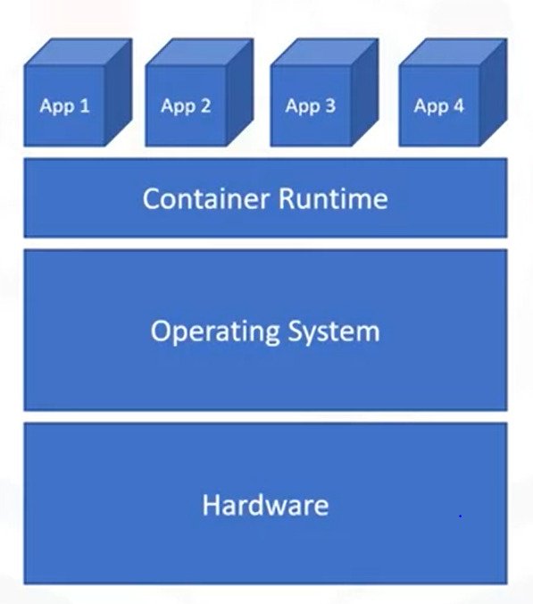

* *Docker is also a container runtime.*
* *A container runtime is the software that executes containers much like “docker run” command.*
* *We first have the hardware/infrastructure as the bottom layer. This is the physical machine n which our software runs.*
* *On top of that we have an operating system. Containers share the operating system rather than just the hardware as virtual machines do.*
* *With containers we have both the hardware and the operating system on the bottom of our stack.*
* *Next comes the container runtime like Docker- this is the layer that runs the container.*
* *Finally, on top, we have applications that we run as containers.*
* *Docker has also introduced the “****containerd runtime”*** *which is quickly gaining popularity.*

***Building Container Images:***

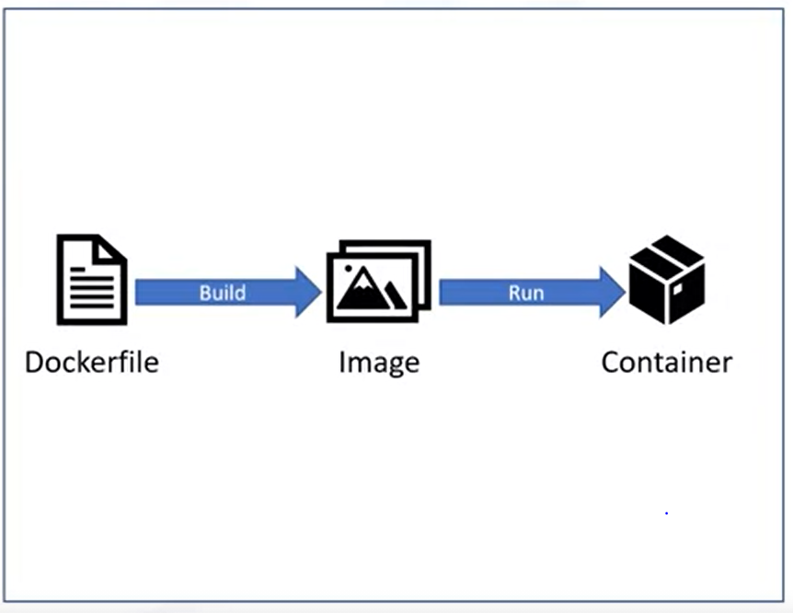

* *The diagram shows the development process of a runtime container.*
* *A* ***dockerfile*** *serves as the blueprint from which an image is built.*
* *The* ***Dockerfile*** *outlines all steps to be taken to build the desired image.*
* *Docker then builds that image.*
* *It is important to know the difference between the container and image which can also be called container image. These aren’t interchangeable terms but rather two distinct things.*
* *An image is an immutable file that contains the source code, libraries and dependencies that are necessary for an application to run.*
* *That immutability means that the images are read-only; if you change an image it will create a new image.*
* *In the sense, images are templates or blueprints of the container. You can also think images as snapshots of the container.*
* *A* ***container*** *is therefore a running image. Since, images are read-only, a write layer is placed on the top of images to enable the container to execute.*
* *To relate this to object-oriented programming, a container image is like a class and a container is an instantiated object of that class.*

***Development of Container:***

* *As shown above, you begin with a DockerFile that indicates what to include in an image.*
* *You build an image using the DockerFile*
* *Then you can run that image you have a running container.*

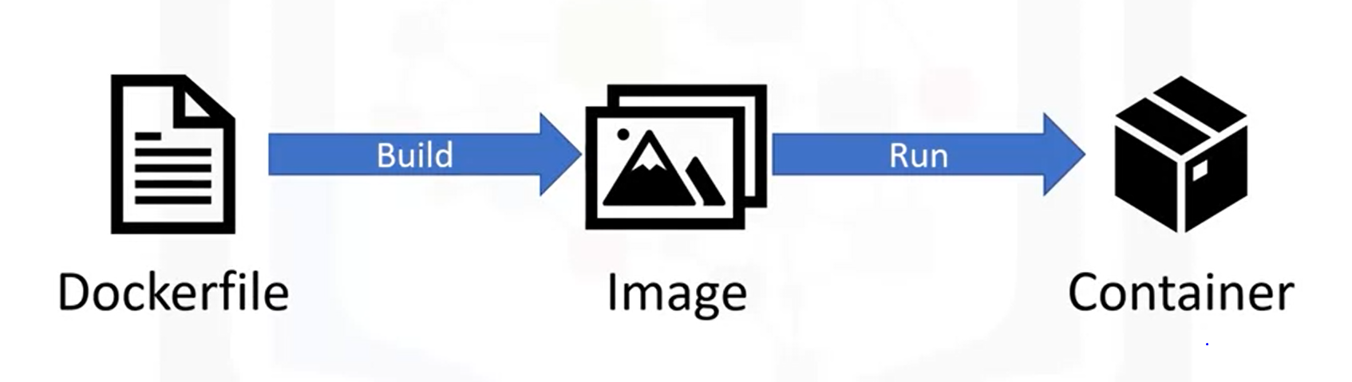

* *These three are the basic steps in the container development process.*

***Image Fil***e:



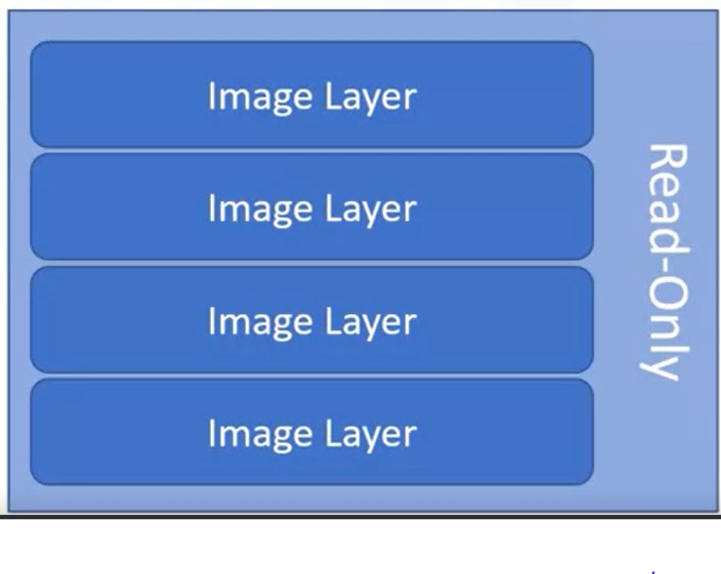

*Docker can automatically build container images by using the instructions from the Dockerfile.*

* *A Dockerfile is simply a text file that contains all the commands a user would call on the command line to create the image.*
* *Docker provides a set of instructions that make this process a bit more straightforward.*
* *Images are then built layer by layer with each Docker instruction creating a new layer on top of the existing layers.*
* *As Docker instructions are run, new read-only layers are created for the image.*
* *Depending on the size of an image, there can be few layers or many.*
* *When all the Docker instructions from a Dockerfile have been executed, the image is built and complete.*
* *Again, this is a read-only image; making a change would result in a new image*
* *Running an image results in container. When we instantiate this image, we get running container. At this point, a writeable container layer is added at top.*
* *Containers are not immutable like images are. Containers are running, performing operations, and performing whatever function the developers have written.*
* *This writeable layer enables the container to execute its function. Note that layers can be shared between the images.*
* *If two images have a layer in common, that layer can be used by both images without having to recreate it.*
* *This can save a lot of disk space and network bandwidth when sending and receiving images.*
* *There are several instructions recognized and provided by Docker for use in Dockerfiles.*

***Dockerfile Instructions:***

***FROM:***

* *Any valid dockerfile must begin with a FROM instruction, which initializes a new build stage and specifies the base image that subsequent instructions will build upon.*
* *The base image is often from a public repository, like an operating system or a base image for a specific language like Go or Node.js*
* *This base image is the starting point for the rest of your image.*

***RUN:***

* *The Run instruction executes commands. For example, you can put a bash command in a RUN instruction to perform a desired action.*
* *Each instruction is a new layer added on top of the previous layers.*

***ENV:***

* *The ENV command enables you to set environment variables in the image.*

***ADD and COPY:***

* *The ADD and COPY commands are similar and enable you to copy files into your image.*
* *The main difference between these two is that COPY can only copy local files or directories. While ADD can also add files from remote URLs.*

***CMD:***

* *Define default command for container execution. If you include more than one, only the last one will take effect. The main purpose for this instruction is to provide a default for executing a container.*
* *This instruction often defines the executable that should run in a container.*

***Here is an example of Dockerfile:***

* *The first command as always is a “FROM” command.*
* *Remember that this command defines the base image. In this case, our base image is Ubuntu version 18.04*
* *This image is freely available on Docker Hub, so we don’t need any authorization and we can also omit the hostname.*
* *Next is the copy command. This command presumes that we have a directory called “app” in our working directory.*
* *Assuming that we do, the directory and its contents will be copied into our image as a new layer.*
* *The Run command performs a “make” operation to build the application.*
* *Finally, the CMD instruction provides a default mechanism for running this container.*
* *As you see, Dockerfiles are simple to construct and use. There are more advanced patterns for optimizing your Dockerfiles and building images more efficiently but in general, these basic operations open to you the powerful world of containerization.*

***Container Registries:***

* *Container images can be stored on your local machine*
* *If you run the “****docker build****” command and build a container image, its now stored on your computer. But this isn’t particularly helpful for distributing that image to others or using it in a staging or production environment.*
* *You need a place where container images can be easily stored and retrieved.*
* *A container registry is used for the storage and distribution of named container images.*
* *While many features can be built on top of a registry, its most basic function is storing images and allowing someone to later retrieve them.*
* *Registries can be public or private. When an image is pushed to a public registry, anyone can pull that image. This is useful for open source projects or personal development where you don’t mind if others use or inspect your images.*
* *Most enterprises will opt to use a private registry, which restricts access to the images so that only authorized users can view and use them.*
* *Registries can also be hosted or self-hosted. Several hosted registries are available, such as IBM Cloud Container Registry.*
* *In this case, the user doesn’t need to deploy or maintain the registry in anyway that’s done by the provider.*
* *The user can use the registry as they wish. However, they are also registry offerings that can be run in private data centers or on a cloud.*
* *The functionality is largely the same in either case, but different individuals and enterprises will have different constraints and intensions that guide their choices.*

***Terminologies:***

* *When storing an image in a registry, we say that you “****push****” an image to the registry.*
* *Similarly, when retrieving an image from the registry we say that you “****pull****” an image.*
* *Images are often pushed by developers or through automation and a build pipeline that they have setup.*
* *Those images can then be pulled to a local machine, although they are often pulled by systems running in the cloud or premises such as Kubernetes.*

***Image Naming:***

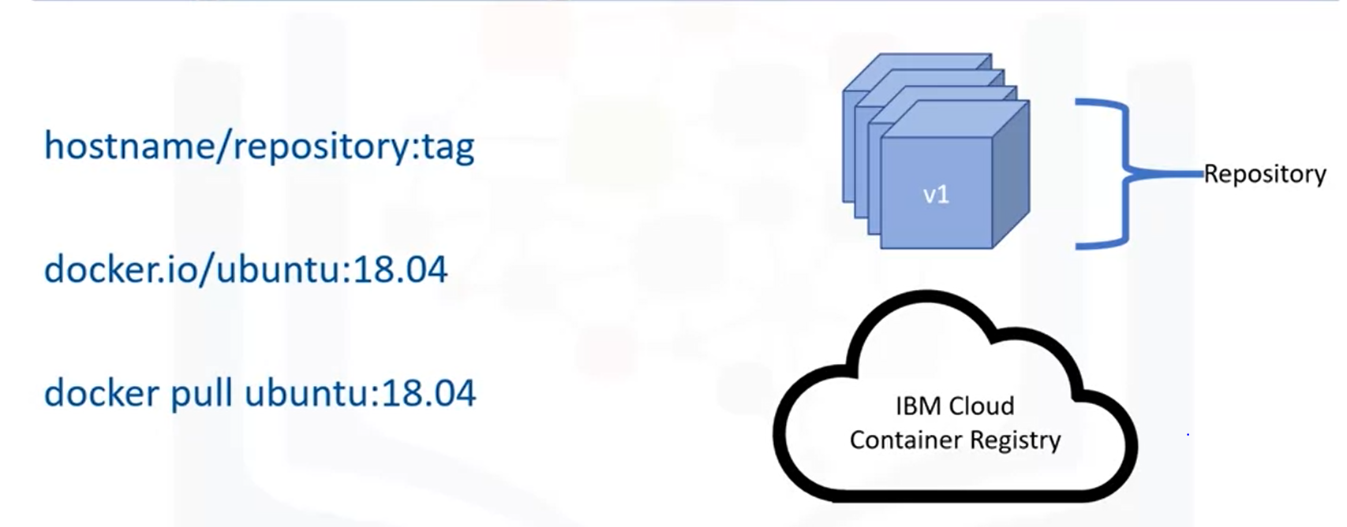

* *The image name usually consists of three parts: the hostname, the repository and the tag.*
* *Hostname/repository:tag*
* *The hostname identifies the registry to which this image should be pushed. For dockerhub, the registry is “docker.io”. For IBM Cloud Container Registry, the registry is “us.icr.io”, if you are pushing to the registry in the US.*
* *A repository is a group of related container images. Usually these will be different versions of the same application or service so the name of the application or service makes a good repository name.*
* *Finally, we have a tag. The tag provides information about a specific version or variant of an image. The tag is often a version number, or it could indicate some other characteristic of the image, such as the operating system on which it was built.*
* *The image name is straightforward. The hostname “docker.io” shows that we are pulling the image from Docker Hub. (docker.io/ubuntu:18.04) docker.io-> hostname, repository- ubuntu, tag-18.04*
* *In fact, the Docker CLI infers the docker.io hostname if it is executed, so we could run this simpler command to pull this image.*

***IBM CLOUD CONTAINER REGISTRY:***

* *The cloud container registry is depicted in the below image.*
* *The top left box shows capabilities provided by IBM Cloud Container Registry.*
* *There is an API for interacting with images as well as IBM-provided public images and private repositories to which users can push their own images.*
* *A feature called Vulnerability Advisor scans images for common vulnerabilities and exposures.*
* *By ensuring security before a vulnerability can be exploited, companies are safeguarded from financial losses and negative press.*
* *The bottom left shows that users can interact with the registry through a command line or graphical user interface.*
* *Finally, at the far right is IBM Cloud Kubernetes service, which provides authentication to IBM Cloud Container Registry out of the box, making it is easy to deploy images from registry as containers on the Kubernetes service.*
* *These are just few examples, but they show that container registers are much more capable and powerful than a merge storage service.*

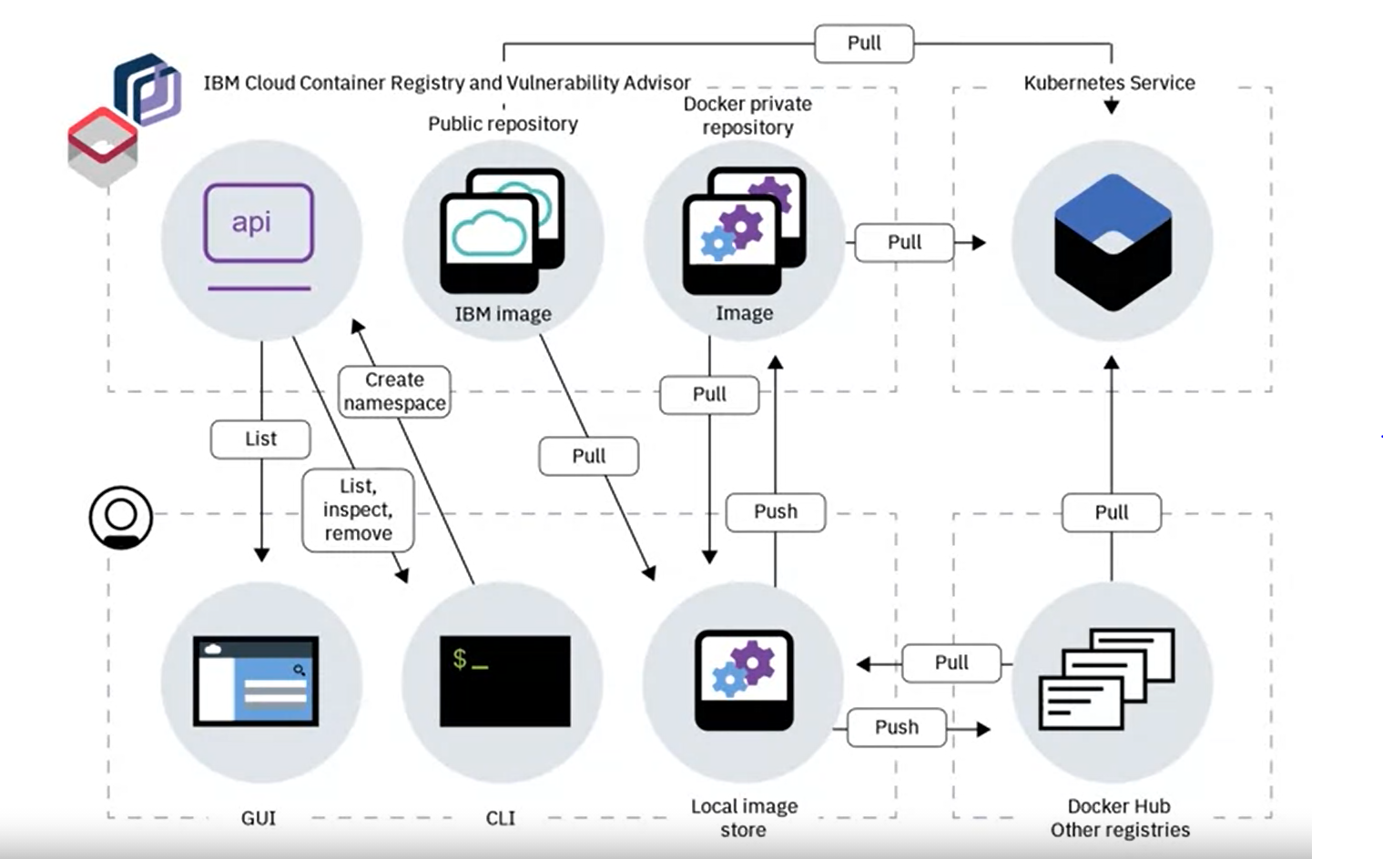

* *The functionality built on top of the container register boosts their appeal and helps developers work more securely and productively.*

***RUNNING CONTAINERS:***

* *This docker file provides the steps for building an image that will run a Node.js application.*
* *Assuming that the file exists we can create an image.*

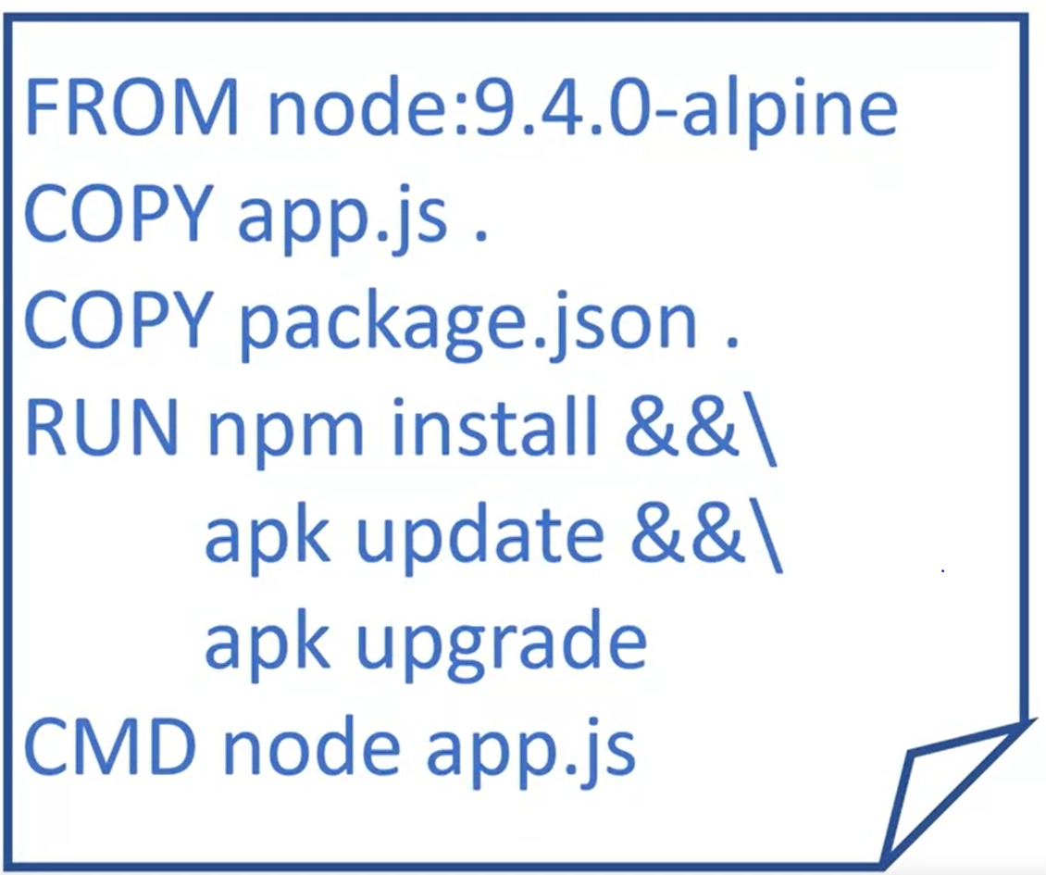

* *A node base image is used, the artifacts are copied to our image, the Node dependencies are installed along with some updates and the “node” command is used to execute the application in a container.*
* *The docker build command uses the DockerFile to create an image.*
* ***Command: docker build -t my-app:v1 .***
* *The -t option indicates the tag option. This specifies the name we want to give to our image.*
* *Remember, the name consists of the hostname, which can be omitted if we are pushing to dockerhub; the repository; and the tag.*
* *In this case, we will push to Docker Hub, so we don’t have a hostname.*
* *The repository name will be my-app and the tag version “v1”.*
* *Last you see a period at the end of the command. This isn’t a typo – a period is shorthand for the current directory.*
* *The last argument for this command is what’s known as the* ***build context.*** *This is the set of files located at this path or URL that will be used for generating your image.*
* *Note that you could also write out a full path to the build context.*

***Output:***

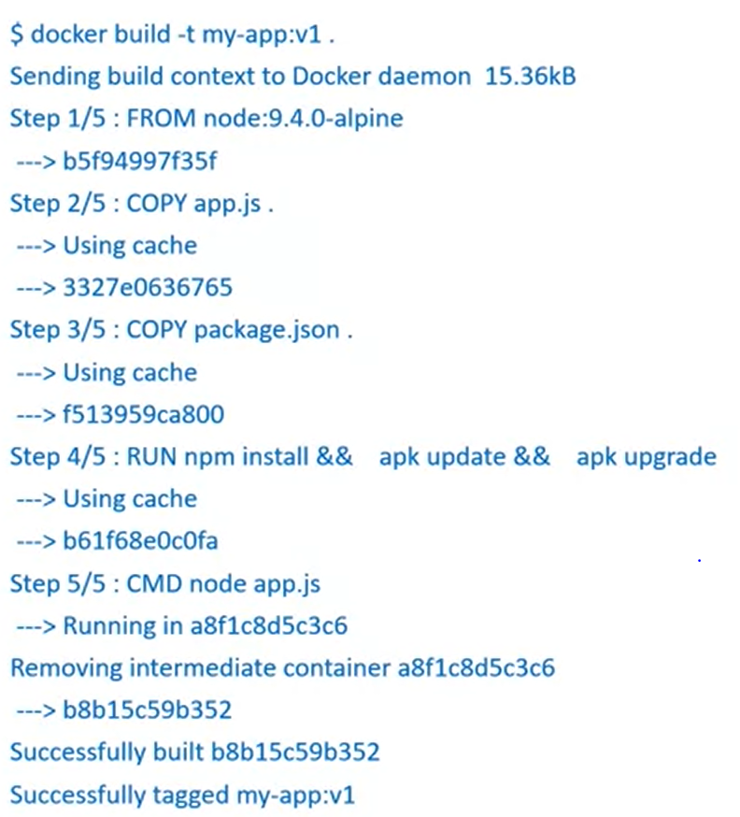

* *First, the build context is sent to the Docker daemon. Then the docker instructions are executed in order.*
* *You can see that each step in this output corresponds to one of the instructions from our DockerFile.*
* *At the end, the image is successfully built and it is tagged as we stipulated.*
* *To verify, we can use the “docker images” command.*

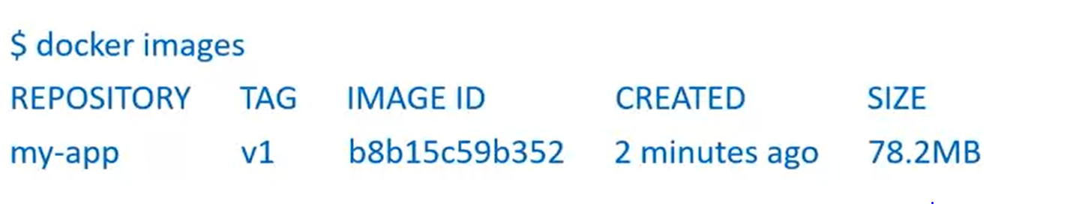

* *The docker tag command first takes the image that you want to tag in this case “my-app:v1” and the second app “second-app:v1”. If we run the below command we will end up with a second tag in our “docker images” output.*

*Docker tag my-app:v1 second-app:v1*

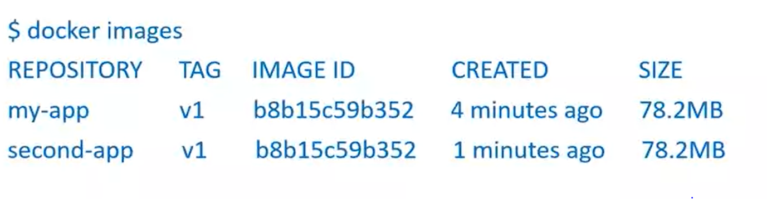

* *If we notice both the images have same ID. As the image isn’t changed. These both images will perform the same function. The only difference is that they are tagged in two different ways.*
* *Now that we have an image lets run it as a container.* ***$docker run my-app:v1***
* *Now let’s push the image to repository. The repository name identifies the registry that the image will be pushed to, so all we need to do is perform a “docker push” command.*

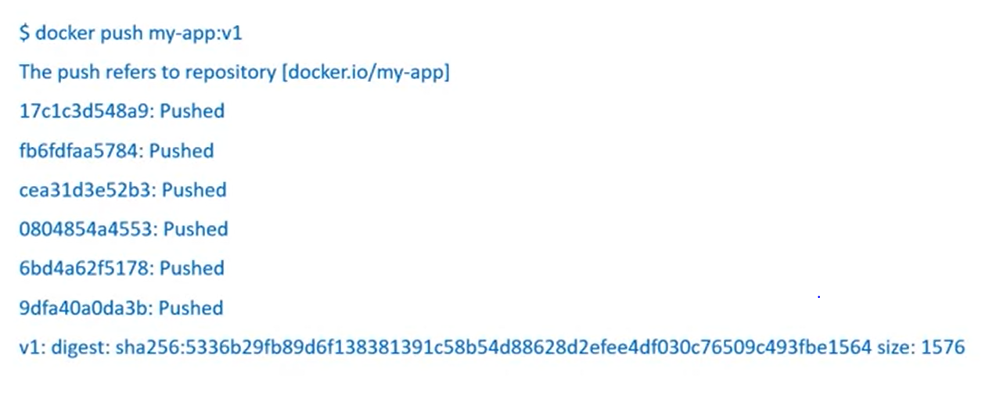

* *The output here shows that each layer of our image is pushed successfully.*

***IBM Cloud:***

* *The IBM Cloud platform is deployed across data centers around the world. It combines platform as a service (PaaS) with infrastructure as a service (IaaS) to provide an integrated experience. The platform scales and supports both large enterprise businesses and small development teams and organizations.*
* *The platform is built to support your needs, whether it's working only in the public cloud or taking advantage of a multicloud deployment model. IBM Cloud offers a variety of services, including Compute, Network, Storage, Management, Security, Databases, Analytics, AI, and Cloud Paks.*

***About IBM Cloud Container Registry namespaces***

* *IBM Cloud Container Registry is a multi-tenant registry in the public cloud. Namespaces are used to provide isolation for users' images. The namespace is a slice of the registry to which you can push your images. The namespace will be a part of the image name when you tag and push an image. For example, us.icr.io/<my_namespace>/<my_repo>:<my_tag>.*

# ***Create an IBM Cloud account***

* *Go to IBM Cloud Sign Up Page: (*[Sign up for IBM Cloud](https://cloud.ibm.com/registration?utm_medium=Exinfluencer&utm_source=Exinfluencer&utm_content=000026UJ&utm_term=10006555&utm_id=NA-SkillsNetwork-wwwcourseraorg-SkillsNetworkCoursescc20117568655-2021-01-01&target=%2Fkubernetes%2Fregistry%2Fmain%2Fstart))
* *Follow the steps to create your account. You will need to provide an email address and password, as well as some personal information. You'll have to verify your account by accessing your email.*
* *Once you created account, login to the account.*

***Create a Container Registry Namespace:***

* *Click Catalog. Search the Container Registry*
* *Once it opens, click on “Get Started”*
* *Ensure the location is set to “Dallas”.*
* *Click the Namespaces tab*
* *On the right side of the Namespace panel, click Create. A Create Namespace panel opens.*
* *In the Resource group field, select the name of the resource group you would like this namespace to reside in.*
* *In the Name field, type a unique name for namespace. The name must be unique across all the container registry service in this region.*
* *Click on Create at bottom. Now you have a namespace to which you can push the images to.*

***Handson:***

* *Open a terminal window by using the Menu in the editor. Terminal-> New Terminal*
* *Verify that the docker cli is installed. Run this command****: docker –version***
* *Verify that ibmCloud CLI is installed. Run this command:* ***ibmcloud version***
* *Change to your project folder. Run:* ***cd /home/project***

*Clone the git repository that contains the artifacts.* **git** clone https://gitlab.com/ibm/skills-network/courses/cc201.git

*Change the directory to this lab-* **cd** cc201/labs/1_ContainersAndDocker/

* *List the contents of this directory to see the artifacts Eg: ls*
* 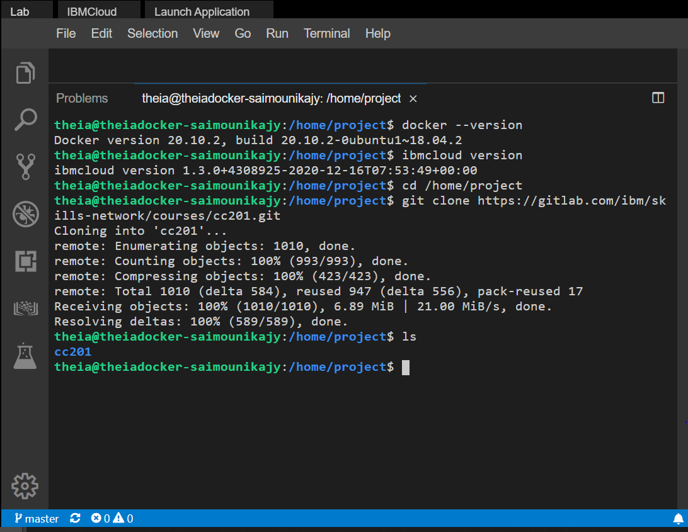

***Pull an image from Docker Hub and run it as a container:***

* *Use the docker CLI to list your images. Eg:* ***docker images***
* *Pull your first image from Docker Hub. Eg:* ***docker pull hello-world***
* *List images again to see this image in the local environment. Eg:* ***docker images***
* *Run the “hello-world” image as a container Eg:* ***docker run hello-world***
* *List the containers to see that your container ran and exited successfully.* ***Eg: docker ps -a***
* *Among other things, for this container you should see a container ID, image name(hello-world) and a status that indicates that the container exited successfully.*
* *Note the container ID from the previous step, and remove the container now that we have run it. Eg:* ***docker container rm <container-id>***

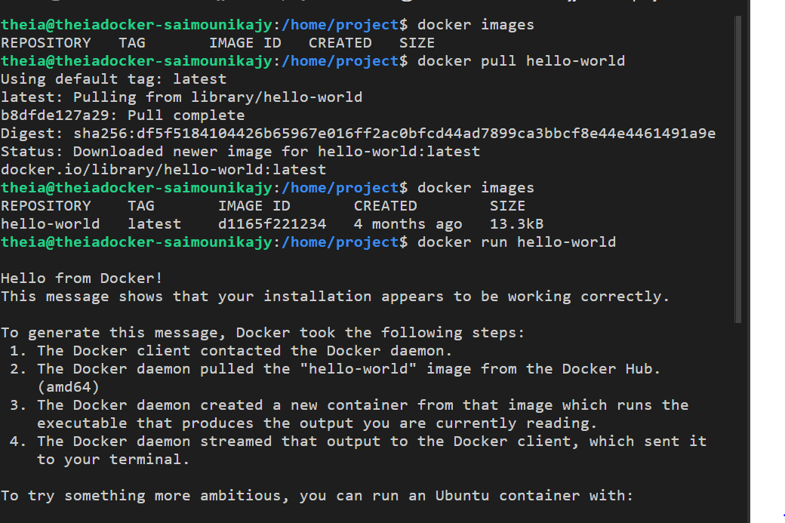

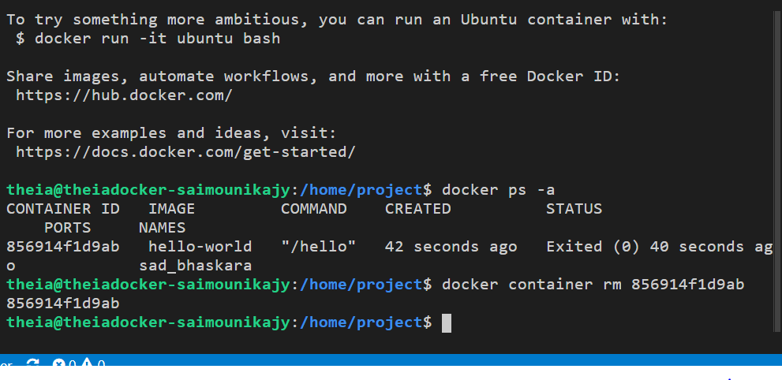

***Build an image using a Docker file:***

* *The current working directory contains a simple Node.js application that we will run in a container. The app will print a hello message along with the hostname. The following files are needed to run the app in a container.*
* *App.js is the main application, which simply replies with a hello world message.*
* *Package.json defines the dependencies of the application.*
* *Dockerfile defines the instructions Docker uses to build the image.*
* *Use the Explorer to view the files needed for this app. Click the Explorer icon (it looks like a sheet of paper) on the left side of the window, and then navigate to the directory for this lab: cc201 > labs > 1_ContainersAndDocker. Click Dockerfile to view the Dockerfile we'll use to build an image. If you don't understand any of the instructions in the Dockerfile, review the module videos.*

FROM node:9.4.0-alpine

COPY app.js .

COPY package.json .

RUN npm install &&\

    apk update &&\

    apk upgrade

EXPOSE  8080

CMD node app.js

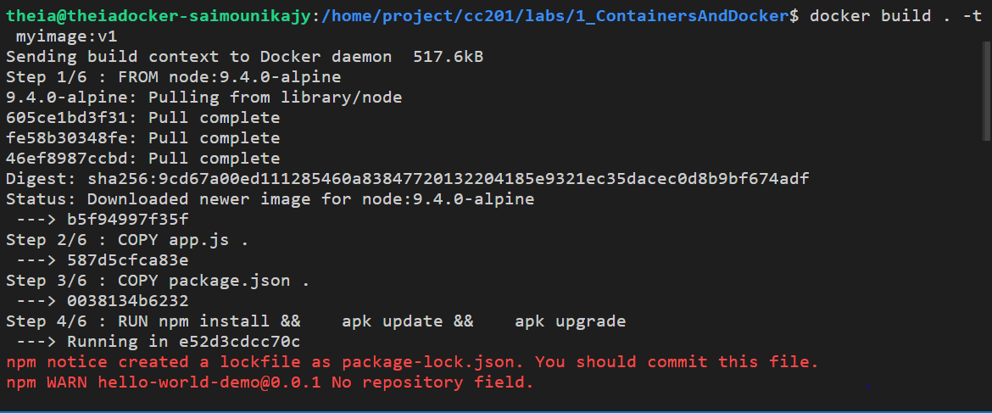

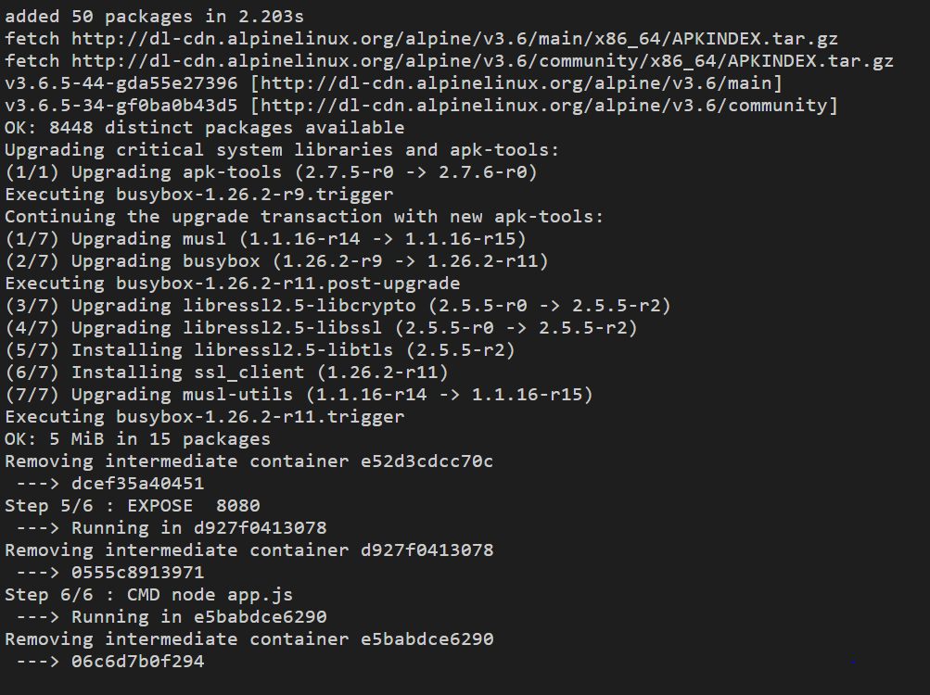

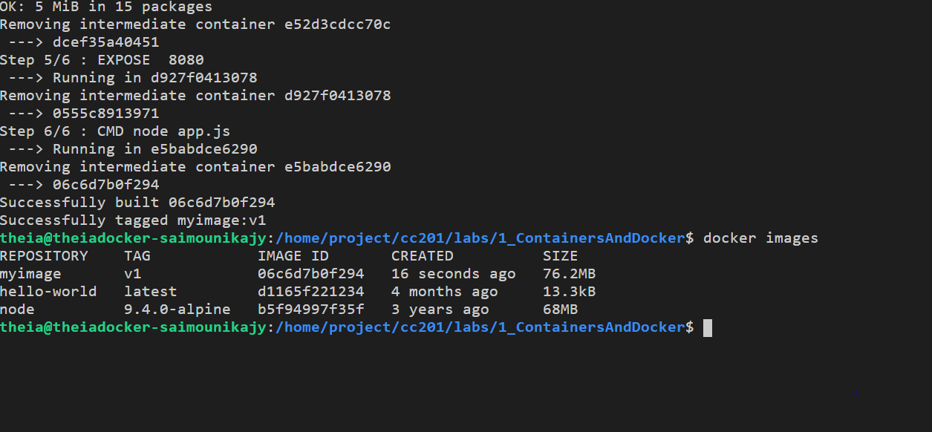

***Run the image as a container:***

* *Now that the image is built, run it as a container. Command:* ***docker run -p 8080:8080 myimage:v1***
* *The output should indicate that your application is listening on port 8080. This command will continue to run until it is quit, since the container runs as a web app that continually listens for requests. To query this app, open a new terminal window.*
* *To split the terminal click Terminal-> Split Terminal*
* *In the second window, use the curl command to ping the application. Command:* ***curl localhost:8080.***
* *The output should indicate the app should be up and running.*
* *In the second terminal window, stop the container. The following command uses* ***docker ps -q*** *to pass in the list of all running apps. Command:* ***docker stop $(docker ps -q)***
* *Close the second terminal window as it is no longer needed. Command:* ***exit***

***Push the image to IBM Cloud Container Registry:***

* *Login to the IBM cloud account. Command:* ***ibmcloud target***
* *The environment also has an IBM Cloud Container Registry(ICR) namespaes for you. Since, Container Registry is multi-tenant, namespaces are used to divvy up the registry among several users. Command:* ***ibmcloud cr namespaces***
* *You should see two namespaces listed starting with sn-labs. The first one with your username is a namespace just for you. The first one with your username is a namespace just for you. You have full read and write access to this namespace.The second one is a shared namespace you only have read access to. Ensure that you are targeting the us-south region where these namespaces reside as you saw in the output of the ibmcloud target command.*
* ***ibmcloud cr region-set us-south***
* *Log your local Docker daemon into IBM Cloud Container Registry so that you can push to and pull from the registry.*

***ibmcloud cr login***

* *Export your namespace as an environment variable so that it can be used in subsequent commands.*

***export MY_NAMESPACE=sn-labs-$USERNAME***

* *Tag your image so that it can be pushed to IBM Cloud Container Registry.*

***docker tag myimage:v1 us.icr.io/$MY_NAMESPACE/hello-world:1***

* *Push the newly tagged image to IBM Cloud Container Registry.*
* ***docker push us.icr.io/$MY_NAMESPACE/hello-world:1***
* *Verify that the image was successfully pushed by listing images in Container Registry.*

*ibmcloud cr images*

*Optionally, to only view images within a specific namespace.*

***ibmcloud cr images --restrict $MY_NAMESPACE.***

* *You should see your image name in the output. Recall from the module videos that we discussed Vulnerability Advisor, which scans images in IBM Cloud Container Registry for common vulnerabilities and exposures. In the last column of the output, note that Vulnerability Advisor is either scanning your image or it has provided a security status, depending on how quickly you list the images and how long the scan takes.*

***Container Orchestration:***

* *Everyone’s container journey starts with one container. Overtime, new applications are written and deployed, applications grow and take on new components that are deployed independently and projects spread across the globe to increase availability.*
* *That one initial container inevitably becomes many containers.*
* *As your container footprint grows and evolves, a tool for managing the lifecycle of your containers becomes increasingly necessary.*
* ***Container Orchestration*** *aids in provisioning and deployment of containers to make this a more automated, unified and smooth process.*
* ***Container Orchestration***  *also ensures that containers are redundant and available so that applications experience minimal downtime.*
* *It scales containers up and down to meet demand, and it load-balances requests across instances so that no one instance is overwhelmed.*
* *It handles the scheduling of containers to underlying infrastructure.*
* *Lastly, container orchestration tools can perform healthchecks to ensure that applications are running and these tools can take necessary actions when checks fail.*
* *Although, several container orchestration tools exist, Kubernetes has established itself as the premier platform of choice.*

***What Kubernetes is?***

* ***Kubernetes, is a portable, extensible opensource platform for managing containerized workloads and services that facilitates both declarative configuration and automation. It has a large, rapidly growing ecosystem. Kubernetes services, support and tools are widely available***
* *Highlights: First, Kubernetes is open-source software. Contributors from all over the world, from a variety of companies and industries contribute to Kubernetes and the code, roadmap and much mor found online.*
* *Kubernetes is designed specifically as a container orchestration platform.*
* *Kubernetes facilitates declarative management – a desired state that can be expressed.*
* *For eg., the number of replicas of a specific application – and Kubernetes will actively work to ensure that the observed state matched the desired state.*
* *There is a progressive growing ecosystem for Kubernetes.*
* *And finally, Kubernetes is widely available and has positioned itself as the de facto.*

***What Kubernetes is not?***

* *Not a traditional, all-inclusive platform as a service(PaaS).*
* *Doesn’t limit type of applications. Whatever languages and frameworks that are suitable as long as they can be containerized.*
* *If an application can run in containers then it can run on Kubernetes.*
* *Kubernetes doesn’t provide Continuous Integration/Continuous Deployment pipelines to build applications or deploy source codes.*
* *Similarly, logging, monitoring and alerting solutions aren’t prescribed. Third party or open source tools can be chosen and integrated.*

***Kubernetes Architecture:***

* *A deployment to Kubernetes is called a “cluster”.*
* *On the left side of the diagram is the control pane, which makes decisions about the cluster and detects and responds to events in the cluster.*
* *An example of a decision made by the control plane is scheduling of workloads.*
* *An example of responding to an event is creating new resources when an application is deployed.*
* *The control plane consists of several components.*
* 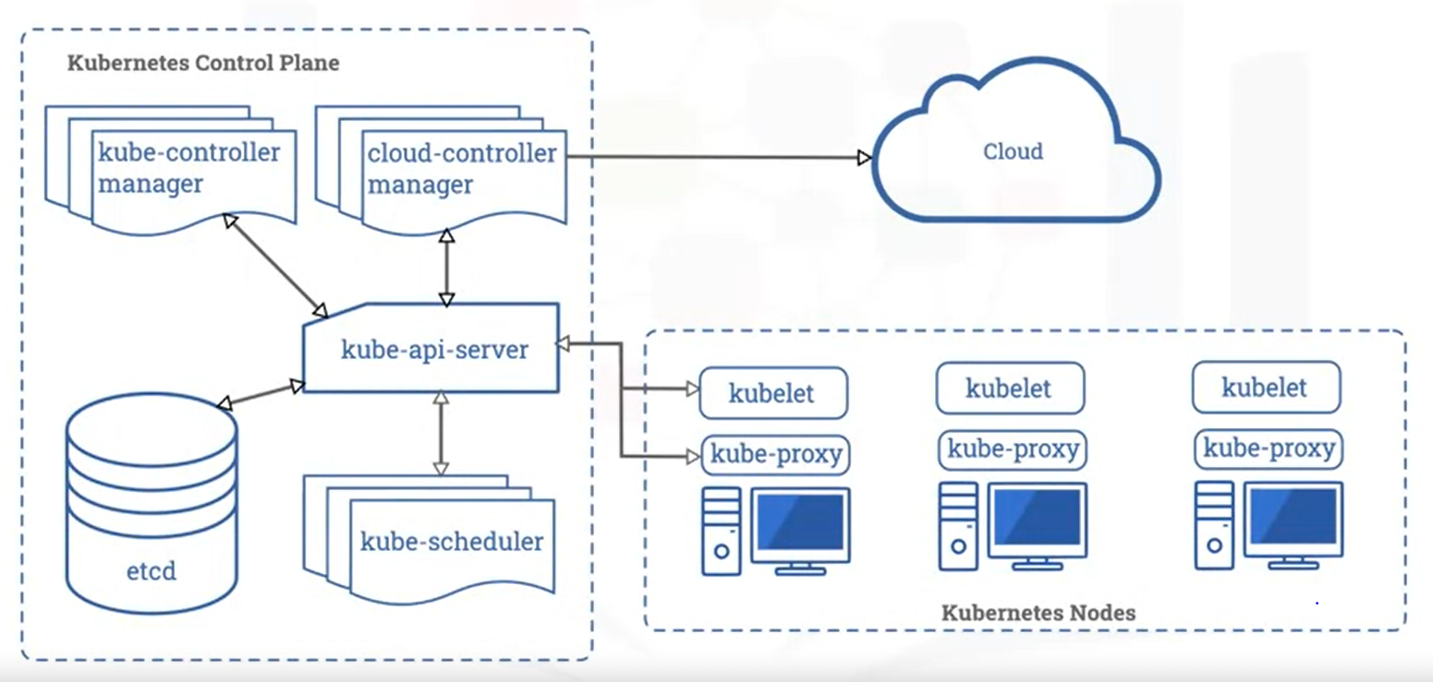

***Kubernetes API Server:***

* *First is the Kubernetes API Server, which exposes the Kubernetes API.*
* *All communication in the cluster utilizes this API.*
* *For Example, the Kubernetes API server accepts commands to view or change the state of the cluster.*

***Etcd:***

* *Next is etcd, a highly available key value store that contains all the cluster data.*
* *When you tell Kubernetes to deploy your application, the deployment configuration is stored in etcd.*
* *Etcd is thus the source of truth for the state in Kubernetes cluster, and the system works to bring the cluster state into line with what is stored in etcd.*

***Kubernetes Scheduler:***

* *The Kubernetes scheduler assigns newly created pods to nodes.*
* *This means that the scheduler will determine where your workloads should run within the cluster.*

***Kubernetes Controller Manager:***

* *The Kubernetes controller manager runs all the controller processes that monitor the cluster state and ensure that the actual state of the cluster matches the desired state.*

***Cloud Controller Manager:***

* *Finally, cloud controller manager runs controllers that interact with the underlying cloud providers. These controllers effectively link clusters into a cloud provider’s API.*
* *Since Kubernetes is an open source software and would ideally be adopted by a variety of cloud providers and organizations, it strives to be as cloud agnostic as possible.*
* *The cloud controller manager enables both the Kubernetes and the cloud providers to evolve freely without introducing dependencies on the other.*

***Worker Nodes:***

* *Nodes are the worker machines in a Kubernetes cluster. In other words, user machines run on nodes.*
* *Nodes can be virtual or physical machines. Each node is managed by the control plane and is able to run pods.*
* *Nodes aren’t created by Kubernetes itself but rather by the cloud provider. This enables Kubernetes to run on variety of infrastructures.*
* *The nodes are then managed by the control plane. The components on a node enable that node to run pods.*
* *First, is the* ***Kubelet****. This Controller communicates with the Kubernetes API server to receive new and modified pod specifications and ensure that those pods and their associated containers are running as desired. The Kubelet also reports to the control plane on health and status.*
* *In order to start a pod, the Kubelet uses the container runtime*

***Container Runtime:***

* *The Container Runtime is responsible for downloading images and running containers.*
* *Rather than providing a single container runtime, Kubernetes implements a container runtime interface that permits pluggability of the container runtime.*
* *While Docker is likely the best known runtime, rkt and CRI-O are two other commonly used container runtimes.*

***Kubernetes Proxy:***

* *It is a network proxy that runs on each node in a cluster.*
* *This proxy maintains network rules that allow communication to Pods running on nodes. In other words, communication to workloads running on your cluster.*
* *This communication can come from within or outside of the cluster*

***Controllers and Control Loop:***

* *Controllers ensure that the actual state of the cluster matches the desired state.*
* *A control loop is defined as a non-terminating loop that regulates the state of a system.*
* *Controllers monitor the state of the cluster. Take action to ensure that the actual state matches the desired state.*
* *Generally, the controller will send a message to the API server to initiate an action that will help bring the current state in line with desired state.*
* *A Kubernetes controller tracks a Kubernetes object.*

***Introduction to Kubernetes object:***

* *These are the persistent entities in Kubernetes.*
* *“Persistent” means that whenever you create an object, Kubernetes continually works to ensure that the object exists in the system, until and unless you modify or remove that object.*
* *In this way, Kubernetes objects define the state of your cluster.*
* *By creating an object, you tell Kubernetes that you expect that object to exist. The system is then responsible for ensuring that that object in fact exist. Some Kubernetes objects are Pods, namespaces, deployments, ConfigMaps and volumes.*
* *To work with these objects – that is to create, update or delete them- you use the Kubernetes API.*
* *The most common way to perform these actions is to use the “****kubectl****” command line interface. The CLI makes the necessary Kubernetes API calls on behalf.*
* *You can also use the API directly by using one of the many client libraries provided by Kubernetes. Kubernetes objects consists of two parts: spec and status*
* *The first is the object “spec” which is provided by the user. The spec dictates the desired state of the object.*
* *The second field is the “status” which is provided by Kubernetes. The status describes the current state of the object. Its actual state as opposed to its desired state.*
* *The status is updated if at anytime the status of the object changes. The goal, of course, is for the desired state to match the current state and Kubernetes.*

***Namespaces:***

* *Namespaces provide a convenient way to virtualize a physical cluster.*
* *With namespaces, you can make one cluster appear to be several distinct clusters.*
* *This is useful when several teams want to share a cluster such as for cost saving purposes or when a team maintains multiple projects and want to keep these projects segregated.*
* *However, namespaces are most useful when there are large number of cluster users.*
* *A cluster will automatically have several namespaces created that are used to house elements of the Kubernetes architecture.*
* *For instance, the Kube-system namespace is present to hold some of these components. Since this namespace is intended for the Kubernetes system, users shouldnot put applications into the namespaces.*
* *Instead, there might be a default namespace, which can be used to hold the user’s applications.*
* *In some circumstances, this situation can be suitable for a user. Perhaps they have only one team using a cluster, and that team only has one project that it deploys into this cluster. In this case, further division might not be necessary.*
* *If, however, there are many teams or many projects or perhaps a lot of users who have different needs, additional namespaces can be created to keep things separate.*
* *A team can have its own namespace or a project can have its own.*
* *Administrators can divvy up a cluster with namespaces at their own discretion.*
* *These are just a few common patterns, but the key point is that namespaces can be used to provide logical separation of a cluster into virtual clusters.*
* *They provide a scope for the names of objects. Each object has a name and that name must be unique for that resource type within that namespace.*
* *For Example, if you have a pod that is named as “myPod” in the default namespace then no other pod in the default namespace can use that name. However, a pod in another namespace can use the same name, since that namespace provides a new scope for that name and a deployment in the same namespace can use the same name since the resource type is different.*
* *Names obviously provide a level of uniqueness within a namespace. But if you want to provide attributes to an object without specifying any uniqueness, labels are great place to start.*

***Labels:***

* *Labels are key/value pairs that can be attached to objects in order to identify those objects.*
* *However, a label doesn’t uniquely identify a single object. Many objects carry the same labels, which enables those objects to be grouped and organized.*
* *Label selectors are the core grouping primitive in Kubernetes. They enable you to identify a set of objects.*

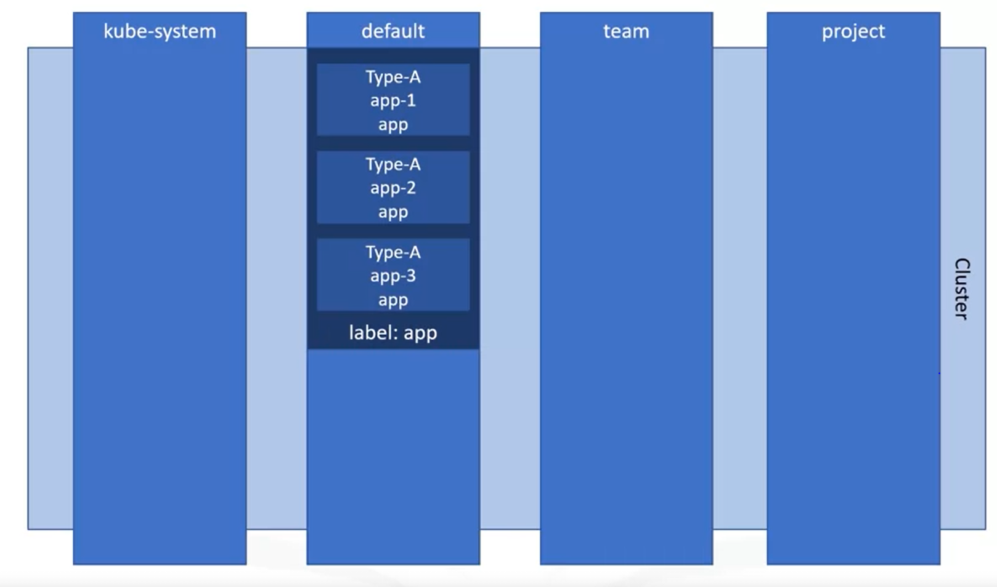

***Pod:***

* *The first object we will learn about is the pod.*
* *The simplest unit that you deploy in Kubernetes. A pod represents a process running in your cluster. It also represents a single instance of an application running in your cluster.*
* *Usually, a Pod wraps a single container although in some cases a Pod can encapsulate multiple tightly coupled containers that share resources.*
* *This is more advanced use case; in general, consider a pod as a wrapper for a single container.*
* *Since a pod is intended to represent a single instance of an application creating replicas of a Pod serves to scale an application horizontally. A container runtime is used to run containers in a pod.*
* *When using the “kubectl” CLI to create objects, you often provide a YAML file that defines the object or objects that you want to create.*
* *Below is an example of YAML file that describes a pod.*
* *The “kind” field is quite simply, the kind of object that you want to create. In this case, we will create a Pod.*
* *The next field that we will highlight is the “spec”. This field differs depending on which kind of object you are creating, so you need to provide the appropriate fields within the spec.*
* *In this case, our spec includes the containers that will run in this Pod.*
* *A* ***Pod Spec*** *must contain at least one container. Remember, there can be multiple containers, but there is usually just one.*
* *The container is named; in the case the name is “nginx”. The image field dictates which image will be run in this Pod.*
* *When using a private registry like IBM Cloud Container Registry, this image name will be longer as it includes the domain as well as the repo and tag.*

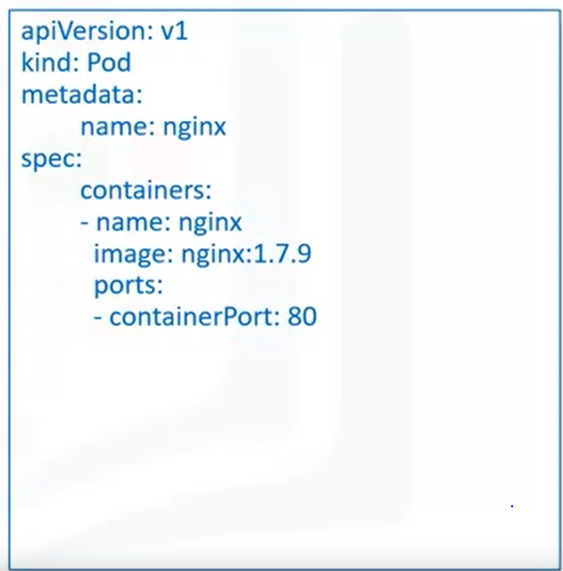

* *Finally, the ports array lists the ports to expose from the container.*

***ReplicaSet:***

* *A ReplicaSet is a group of identical pods that are running.*
* *We previously mentioned that your application can be horizontally scaled by running replicas of a Pod. ReplicaSets are the object used to do this.*
* *A replicaset includes a few key fields that differentiate it from a simple pod definition.*
* *The kind now is a replicaset as that is the object we wish to create.*
* *Since a replicaset is different from a Pod, the spec for this object is different and require different fields.*
* *Perhaps, the most important field here is the replicas field. This field specifies the number of replicas of the defined pod that should be running at any given time.*
* *As this field is set and updated, the ReplicaSet will create or delete pods to meet the desired number of replicas.*
* *A Pod template is also defined in the ReplicaSet spec. This field is important because it defines the pods that should be created by the Replicaset.*
* 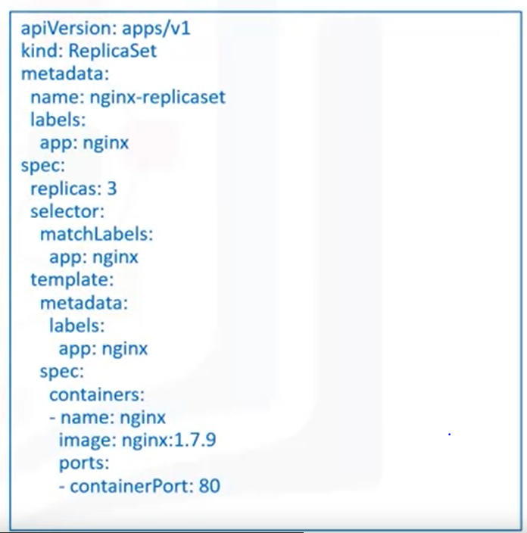
* *As the number of replicas changes, this template dictates how to create the newly desired pods. In this way, a ReplicaSet encapsulates a Pod definition and adds additional information needed to replicate it.*
* *The last field we will discuss is the “selector” field. Labels aren’t unique and selectors are the core grouping primitive in Kubernetes. The labels supplied in this field specify how to identify Pods that can be acquired by the ReplicaSet.*
* *Pods that are acquired by a ReplicaSet possess a reference to the owning ReplicaSet. This link provides the ReplicaSet with needed information on the state of the pods.*
* *Notice that the label identified in the “MatchLabels” field is same as the label in the pod template. Both are “app: nginx”*
* *Interestingly, it isn’t recommended that you create ReplicaSets directly.*
* *Instead, the deployment object, a higher level concept that in turn manages ReplicaSets offers more features and better management, so these are often created directly by users.*
* *In fact, its quite possible that you will never manipulate replicaSets objects directly because the deployment will do that for you.*

***Deployment:***

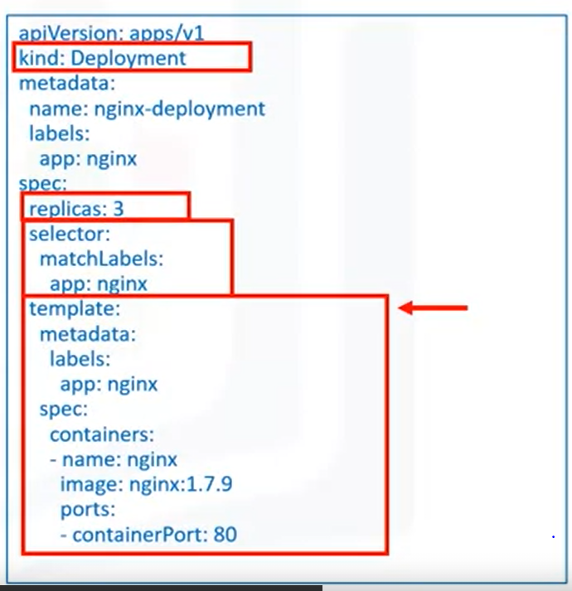

* *A deployment is an object that provides updates for both Pods and ReplicaSets.*
* *Deployments run multiple replicas of an application by creating ReplicaSets and offering additional management capabilities on top of these ReplicaSets.*
* *In addition, deployments are suitable for stateless applications.*
* *Deployments can be used in variety of applications. You might want to deploy a replicated application or update the Pods that are managed by deployment or scale up an application.*
* *Other than simple name change, the definition is identical to the ReplicaSet definition.*
* *This is not the say that the Deployment and ReplicaSet definitions are identical. Deployments are more robust and provide additional objects.*
* *However, a minimalist Deployment can look exactly like a ReplicaSet as defined below. The Kind obviously changes to Deployment but you will still see the number of replicas a selector to identify which Pods can be acquired, and a Pod template.*
* *The replicas field indicates that we want to replicate the Pods in this deployment and that causes a ReplicaSet to be created.*
* *One key feature that Deployments provide that ReplicaSets donot provide is rolling updates.*
* *A ReplicaSet can only define a single Pod template if you want to roll out a new version of your application; you need to create a new deployment that defines a Pod Template.*
* *A rolling update scales up the new version of the appropriate number of replicas and scales down the old version to zero replicas.*
* *A ReplicaSet is therefore effectively responsible for counting pods and ensure that the appropriate number of pods exist, and the Deployment object is responsible for orchestrating the rollout of a new version.*

***Kubectl CLI:***

* *When you work with Kubernetes, one of the key tools you need to familiarize yourself which is the Kubernetes CLI, called “kubectl”.*
* *This tool provides a wide range of functionality for working with Kubernetes clusters and managing the workloads that run in a cluster.*
* *2 key types of commands: “imperative” and “declarative”.*

***Imperative Commands:***

* *Imperative commands enable users to quickly create, update and delete Kubernetes objects.*
* *Imperative commands are easiest to learn and therefore present the lowest barrier to entry. For Example, to create the Pod that runs in a container in this case nginx you can simply run the command:* ***kubectl run nginx –image nginx***
* *This command is simple to write and understand because it only contains a name and image that should be run as a container.*
* *However, it doesn’t provide an audit trail, which is important in clusters so that operators can know what changes are made.*
* *Its also not very flexible the options are limited and additional commands must be run to expose the deployment as an externally available service.*
* *So, you could have one developer run a kubectl run command which would create a pod that runs an application. Another developer on the team might want to deploy that application again. There is no configuration file stored in a repository anywhere. Hence, the second developer would need to ask the first developer for the exact command he ran.*
* *What we need is a template that both developers can use to deploy their application.*
* *And as a matter of fact, there are imperative commands that possess a template. This is known as “****Imperative Object Configuration****”.*
* *In this model, a file contains the configuration template, and the command specifies an operation such as create, replace or delete.*
* *Command****: kubectl create -f nginx.yaml*** *The command specifies a yaml file that contains the object configuration and it specifies that this object should be created.*
* *This is an improvement over basic imperative commands because the configuration template makes replicating the changes much simpler.*
* *All the configuration is available in the file, so its easy to perform this operation. So its easy to perform this operation multiple times and in multiple environments.*
* *Now both developers can refer to the configuration file to ensure that they are deploying the same thing into respective environments.*
* *However, specifying the operation is a limitation of this model. If, for example the first developer performs an update operation that will manipulate the existing operation.*
* *But if that update isn’t merged into the object’s configuration file then the second developer wont be able to use that new configuration when she subsequently deploys the application.*
* *She will indeed use the old configuration. A better option is to define a desired state in that shared configuration file and when that file is applied have Kubernetes determine which operations need to occur. In fact, this is what declarative commands do.*

***Declarative Commands:***

* *Declarative resource management is the most advanced and powerful form of command available in kubectl.*
* *In this model, the configuration files are still used to hold the configuration for an object or several objects.*
* *But in this case, the operation isn’t specified by the user. Rather, the needed operations are detected by Kubectl.*
* *Changes can be made to one file or set of files and the “apply” command can be used to realize the unnecessary changes.*
* *Regardless, of whether what’s needed is to create new objects or update existing objects, the user doesn’t need to know.*
* *By applying the configuration files, Kubernetes takes care of the needed work to actualize the state specified in the files.*
* *In addition, declarative object configuration commands work better on directories, whereas imperative object configuration commands work better on files.*
* *In this case, the first developer can make several updates to the running application. But since he is storing the new configuration in the shared configuration file, there is one source of truth for the configuration for this object.*
* *Now even if the second developer missed several of these updates, she only has to apply the current configuration file and she will be sure that the deployed object is as expected.*
* *Kubernetes will determine which operations must occur to take her cluster’s current state to the desired state, even though she might have missed several intermediate steps taken by the first developer along the way.*
* *Command:* ***kubectl apply -f nginx/*** *This command acts on a directory. All files in the directory will be applied and all necessary changes will be realized in the system.*
* *The user doesn’t even need to know what those changes are.*
* *An operations person will know the current state and the desired changes so that they are aware of whats going on in the system they are administering.*
* *But the point is that those changes don’t need to be explicitly stated by the people creating the configuration objects.*
* *Performing an “apply” command will make the relevant changes automatically.*
* *This is the preferred method for production systems. Imperative commands can be useful during development, but they are not recommended for production.*

***Using Kubernetes:***

* *When the apply command is run, the state of the targeted Kubernetes cluster is made to match the state that’s defined in the provided files.*
* *This is fully declarative. Users don’t need to specify the exact operations that should be carried out. The desired state is all that’s required, and kubectl will determine the specific actions to take. This is incredibly powerful method.*
* *When you create resources, you will want to view them. The “get” and “describe” commands enable to do this.*
* *The “get” command lists one or many resources while the “describe” command shows details about specific resource or group of resources.*
* *Command:* ***kubectl get deployments –namespace kube-system***
* 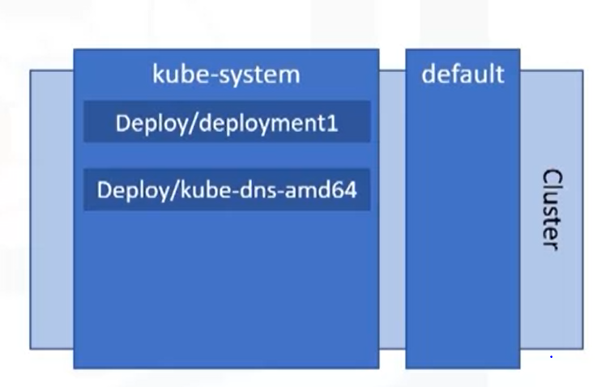
* *Command:* ***kubectl describe deployment kube-dns-amd64 –namespace kube-system***
* *Both commands are namespace scoped meaning that by default they will operate on the resources in the targeted namespace.*
* *The “get” command lists all the deployments in the kube-system namespace.*
* *Kube-system is a namespace for objects created by the Kubernetes system that is its not a user created namespace.*
* *As you can see in the above figure, there are multiple deployments in the kube-system namespace.*
* *The “get” command lists all of those deployments. The “describe” command shows details of a specific deployment in the kube-system namespace called “kube-dns-amd64”*

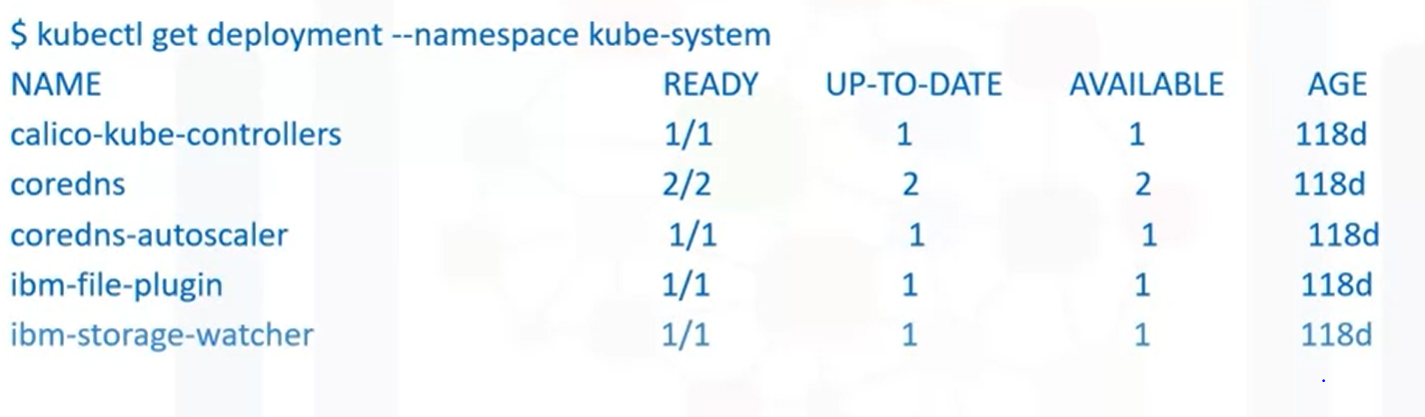

* *It also lists how many of the requested replicas are ready up to date and available as well as when they were created.*
* *This shows basic information like the name, namespace, labels and so on.*
* *The truncated output shows the Pod template as well as some history of this resource Using commands*
* 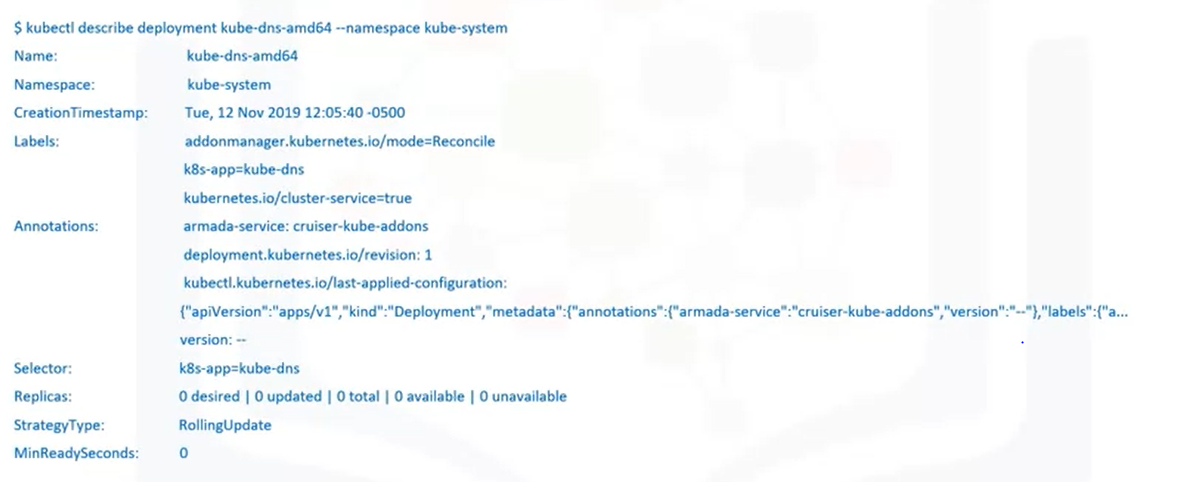

***Creating a resource:***

* *Command****: kubectl apply -f nginx.yaml.***  *We will use the same nginx YAML file.*
* *We will use the same “nginx” YAML file that we displayed previously. It’s a basic deployment configuration that creates three replicas of nginx container image.*
* *We use the apply command which is declarative. That command inferred that a new deployment need to be created.*
* *The output shows that the object was created in the system but we don’t yet know is the object running successfully.*

*Output:* ***deployment.apps/nginx-deployment created***

* *Problems could have occurred pulling an image from registry.*
* *List our deployments to see status-* ***kubectl get deployment***

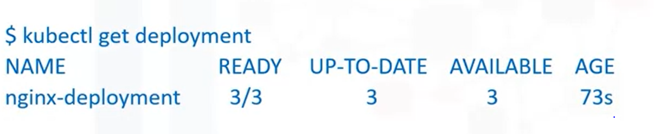

* *As you can see, this resource has three replicas, and all the three are ready, up to date and available.*
* *If we ran “describe” command on this object we could see output as above .*

***Kubernetes Hands On:***

* *Open a New terminal*
* *Verify that Kubectl CLI is installed. Command:* ***kubectl version***

*Output:*

*Client Version: version.Info{Major:"1", Minor:"17", GitVersion:"v1.17.2", GitCommit:"59603c6e503c87169aea6106f57b9f242f64df89", G*

*itTreeState:"clean", BuildDate:"2020-01-18T23:30:10Z", GoVersion:"go1.13.5", Compiler:"gc", Platform:"linux/amd64"}*

*Server Version: version.Info{Major:"1", Minor:"16", GitVersion:"v1.16.10+IKS", GitCommit:"a0052bd119c067cf48e8a19f0ab7d5a5e2ca0a1*

*8", GitTreeState:"clean", BuildDate:"2020-05-20T20:48:06Z", GoVersion:"go1.13.9", Compiler:"gc", Platform:"linux/amd64"}*

* *Change to your project folder: Command:* cd /home/**project**
* *Clone the git repository-> [ ! -d 'CC201' ] && git clone* [*https://github.com/ibm-developer-skills-network/CC201.git*](https://github.com/ibm-developer-skills-network/CC201.git)
* *Change the directory to* ***cd CC201/labs/2_IntroKubernetes/***
* *List the contents of this directory. Command: ls*

***Kubectl Commands:***

* *Kubectl requires configuration so that it targets the appropriate cluster.*

*Command:* ***kubectl config get-clusters***

* *A kubectl context is a group of access parameters including a cluster, a user and a namespace*

*Command****: kubectl config get-contexts***

* *List all the pods in your namespace.*

*Command:* ***kubectl get pods***

* *Create a Pod with imperative command.*
* *Export your namespace as an environment variable so that it can be used in subsequent commands. Command:* ***export My_Namespace=sn-labs-$USERNAME***
* *Run the command to install the packages*

*Command:* ***npm install –save***

* *Create a tar file with the node_modules for use inside the docker*

*Command:* ***tar cvf node_modules.tar node_modules***

* *Use the explorer to view the dockerfile we will use to build an image. Replace the content with the following code*

*FROM node:9.4.0-alpine*

*COPY app.js .*

*COPY package.json .*

*COPY node_modules.tar .*

*RUN tar xvf node_modules.tar*

*EXPOSE 8080*

*CMD node app.js*

* *Build and push the image again*

*Command:* ***docker build -t us.icr.io/$MY_NAMESPACE/hello-world:1 . && docker push us.icr.io/$MY_NAMESPACE/hello-world:1***

* *Run the hello-world image as a container in Kubernetes.*

*Command:* ***kubectl run hello-world --image us.icr.io/$MY_NAMESPACE/hello-world:1 --overrides='{"spec":{"template":{"spec":{"imagePullSecrets":[{"name":"icr"}]}}}}'***

*The –overrides option here enables us to specify the needed credentials to pull the image from IBM Cloud Container Registry. Note this is an imperative command.*

* *List the Pods in your namespace.*

***Kubectl get pods***

*The previous command indeed created a pod for us. You can see an auto-generated name was given to Pod.*

* *You can also specify the wide option for the output to get more details about the resource.*

*Command****: kubectl get pods -o wide***

* *Describe the pod to get more details about it.*

*Command:* ***kubectl describe pod hello-world***

* *Delete the Pod*

*Command****: kubectl delete pod hello-world***

* *List the pods to verify that none exist.*

*Command:* ***kubectl get pods***

***Create a Pod with imperative object configuration:***

* *Imperative Object Configuration lets you create objects by specifying the action to take( Eg: create, update, delete) while using a configuration file. A configuration file, hello-world-create.yaml is provided.*
* *Use the Explorer to view and edit the configuration file. Click the Explorer icon (it looks like a sheet of paper) on the left side of the window, and then navigate to the directory for this lab: CC201 > labs > 2_IntroKubernetes. Click hello-world-create.yaml to view the configuration file.*
* *Use the Explorer to edit hello-world-create.yaml. You need to insert your namespace where it says <my_namespace>. Make sure to save the file when you're done.*
* *Imperatively create a Pod using the provided configuration file.* ***kubectl create -f hello-world-create.yaml.*** *Note that this is indeed imperative, as you explicitly told Kubernetes to create the resources defined in the file.*
* *List the Pods in your namespace.* ***Kubectl get pods***
* *Delete the Pod.* ***Kubectl delete pod hello-world.*** *This command can take sometime to run.*

***Creating a Pod with a declarative command:***

* *The previous two ways to create a Pod were imperative -- we explicitly told kubectl what to do. While the imperative commands are easy to understand and run, they are not ideal for a production environment. Let's look at declarative commands.*
* *A sample hello-world-apply.yaml file is provided in this directory. Use the Explorer again to open this file. Notice the following:*
* *We are creating a Deployment (kind: Deployment).*
* *There will be three replica Pods for this Deployment (replicas: 3).*
* *The Pods should run the hello-world image (- image: us.icr.io/<my_namespace>/hello-world:1).*
* *Use the Explorer to edit hello-world-apply.yaml. You need to insert your namespace where it says <my_namespace>. Make sure to save the file when you're done.*
* *Use the kubectl apply command to set this configuration as the desired state in Kubernetes. Command:* ***kubectl apply -f hello-world-apply.yaml***
* *Get the Deployments to ensure that a Deployment was created. Command:* ***kubectl get deployments.***
* *List the Pods to ensure that three replicas exist. Command:* ***kubectl get pods***
* *With declarative management, we did not tell Kubernetes which actions to perform. Instead, kubectl inferred that this Deployment needed to be created. If you delete a Pod now, a new one will be created in its place to maintain three replicas.*
* *Note one of the Pod names from the previous step, and delete that Pod. Eg:* ***kubectl delete pod <pod_name>****. This command can take some time to run.*
* *List the Pods to see a new one being created. Command:* ***kubectl get pods***
* *If you do this quickly enough, you can see one Pod being terminated and another Pod being created.*

*NAME READY STATUS RESTARTS AGE*

*hello-world-dd6b5d745-2jw5s 0/1 Terminating 0 35s*

*hello-world-dd6b5d745-f9xjk 1/1 Running 0 35s*

*hello-world-dd6b5d745-m89fc 0/1 ContainerCreating 0 8s*

*hello-world-dd6b5d745-qvs9t 1/1 Running 0 35s*

*Otherwise, the status of each will be the same, but the age of one Pod will be less than the others.*

*NAME READY STATUS RESTARTS AGE*

*hello-world-dd6b5d745-f9xjk 1/1 Running 0 39s*

*hello-world-dd6b5d745-m89fc 1/1 Running 0 12s*

*hello-world-dd6b5d745-qvs9t 1/1 Running 0 39s*

# *Load balancing the application*

*Since there are three replicas of this application deployed in the cluster, Kubernetes will load balance requests across these three instances. Let's expose our application to the internet and see how Kubernetes load balances requests.*

* *In order to access the application, we have to expose it to the internet using a Kubernetes Service.* ***kubectl expose deployment/hello-world.*** *This command creates what is called a ClusterIP Service. This creates an IP address that accessible within the cluster.*
* *List Services in order to see that this service was created.* ***kubectl get services.***
* *Open a new terminal window using Terminal > New Terminal.*
* *Since the cluster IP is not accessible outside of the cluster, we need to create a proxy. Note that this is not how you would make an application externally accessible in a production scenario. Run this command in the new terminal window since your environment variables need to be accessible in the original window for subsequent commands. Command****: kubectl proxy.*** *This command doesn't terminate until you terminate it. Keep it running so that you can continue to access your app.*
* *In the original terminal window, ping the application to get a response.****curl -L localhost:8001/api/v1/namespaces/sn-labs-$USERNAME/services/hello-world/proxy***
* *Notice that this output includes the Pod name. Run the command ten times and note the different Pod names in each line of output.*
* *for i in `seq 10`; do curl -L localhost:8001/api/v1/namespaces/sn-labs-$USERNAME/services/hello-world/proxy; done*
* *You should see more than one Pod name, and quite possibly all three Pod names, in the output. This is because Kubernetes load balances the requests across the three replicas, so each request could hit a different instance of our application.*
* *Delete the Deployment and Service. This can be done in a single command by using slashes.*

***kubectl delete deployment/hello-world service/hello-world.***

*Return to the terminal window running the proxy command and kill it using Ctrl+C*

***ReplicaSets:***

* *Replica Sets help us scale applications to meet increasing demand.*
* *It manages your pods ensuring that the right number of pods are always up and running. This can mean adding or deleting pods as needed.*
* *ReplicaSets provide the ability to replicate pods and restart or spin up new pods when existing ones failed. A replicaset can pick an existing pod to add to the deployment or create a new one if there are no existing pods.*
* *It does so by asking for a list of pods from the Kubernetes API and then filtering on labels as defined in the descriptor. The ReplicaSet object supersedes the ReplicationController and should be used instead.*
* *IBM Cloud Kubernetes Service will create a ReplicaSet for you when you create a deployment in your cluster. One of the main design philosophies of Kubernetes is to keep each object type independent of the others.*
* *True to this loose-coupling idea, the ReplicaSet doesn’t own any of the pods instead it uses the pod labels to decide which pods to acquire when bringing to deployment to the desired state.*
* *The template metadata inside the YAML spec defines the labels of potential pod candidates to add or delete.*

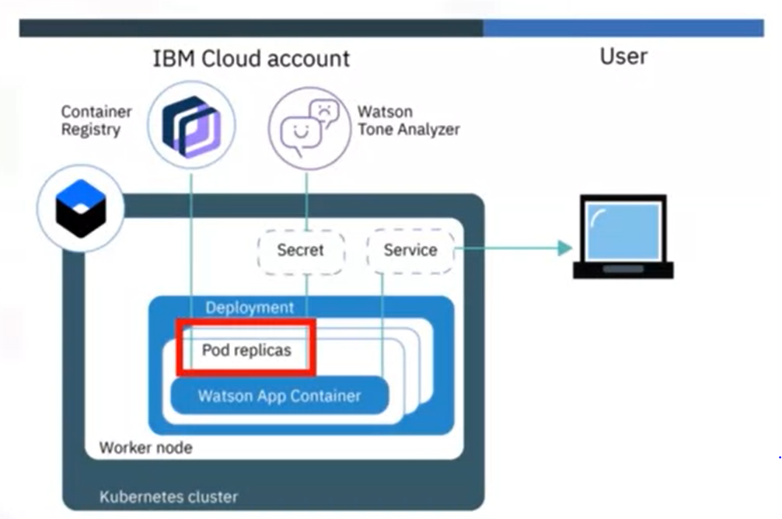

***ReplicaSet- How to Create One?***

* *One was created for you when you created for you when you create a deployment.*

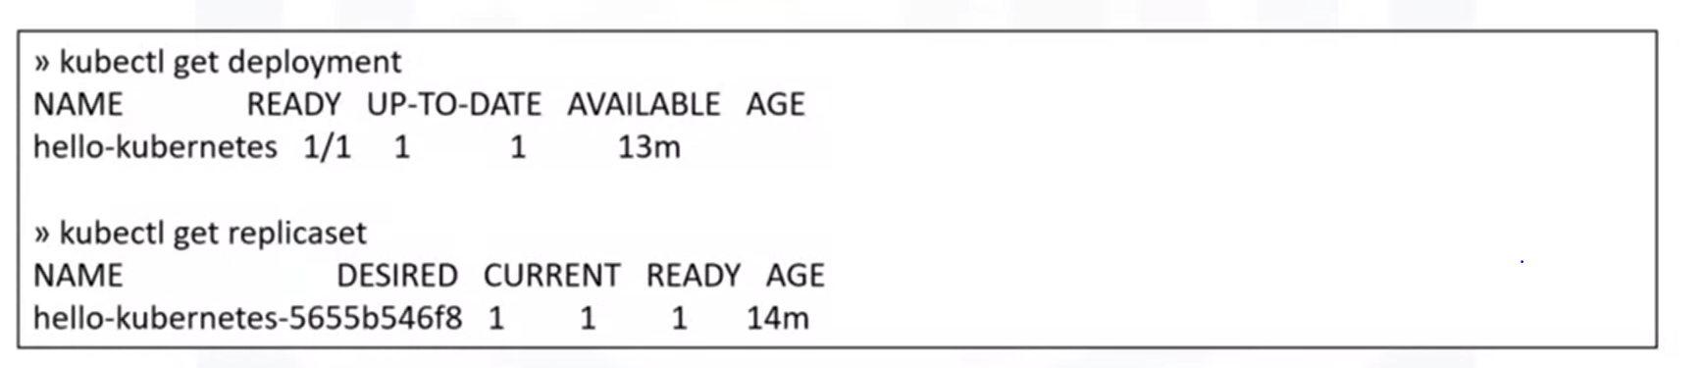

* *The one above which is hello-kubernetes-randomnumber is the default replicaset created.*
* *If you describe the pod, we will see that it is controlled by: the same replica set as shown below.*
* *This is a loose coupling based on the prod labels. To create one from scratch, you can simply apply a YAML file with the “kind” attribute set to “ReplicaSet”.*
* *We see that the number of ReplicaSets is defined as “1” so you get a single pod as when you create a default without specifying the number of replicas in the YAML file.*
* *While its possible to create a replicaset without a deployment its recommended you create a deployment instead. A deployment gives you a couple of additional features.*

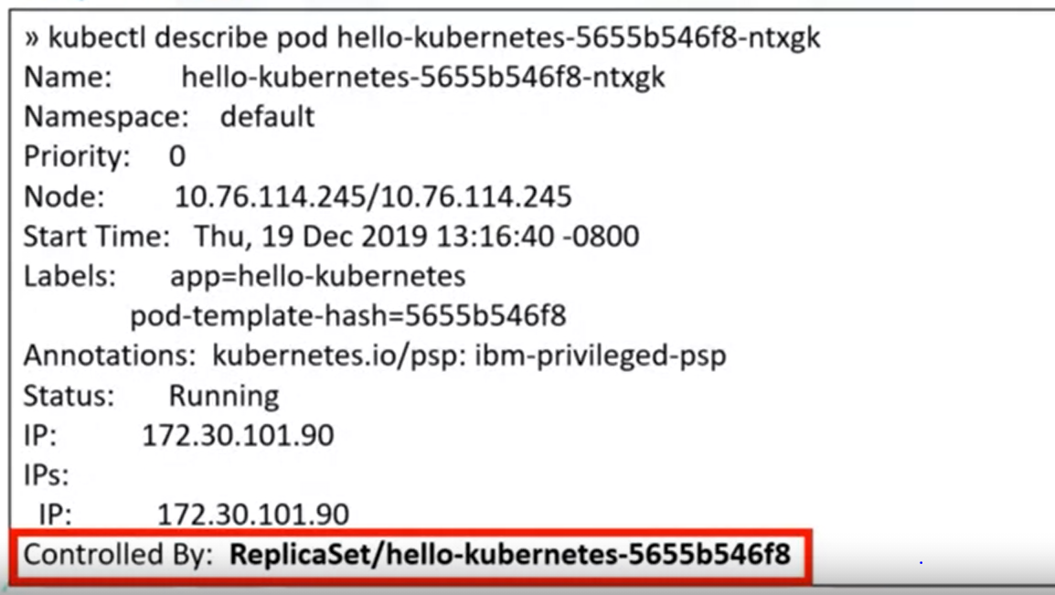

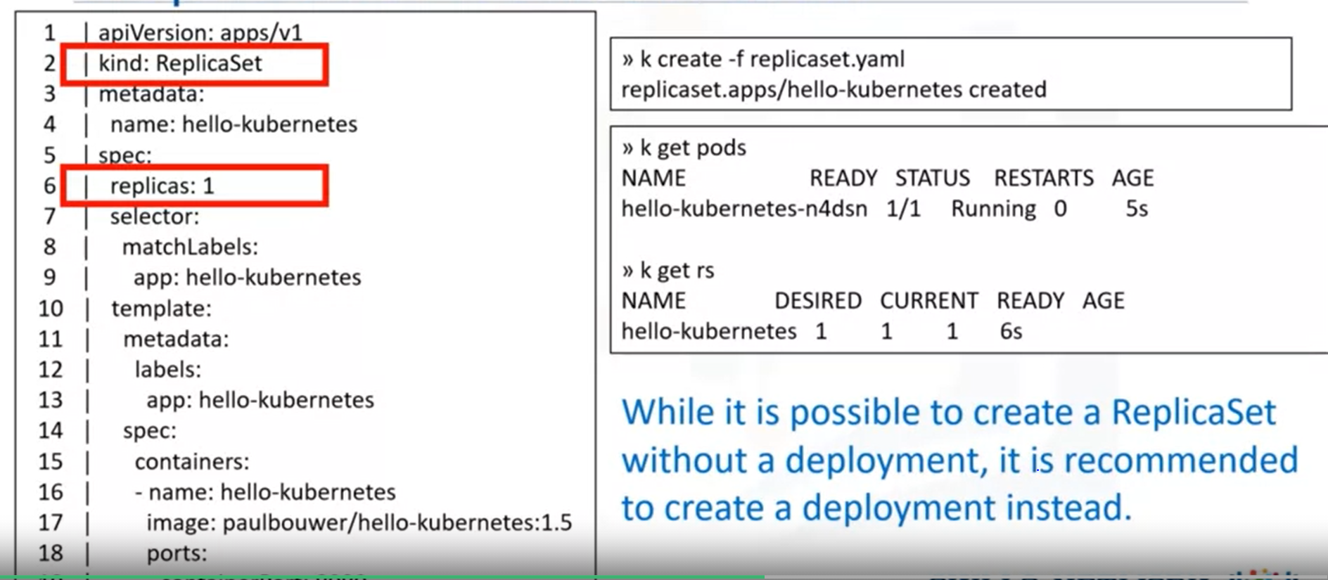

* *Note that the kubectl uses rs as a short form of ReplicaSet, because nobody wants to type more than absolutely necessary.*
* *If you already have a deployment that you want to scale you can simply use the “scale” command. The first command creates a deployment.*

***Command: kubectl create -f deployment.yaml***

*Output: deployment.apps/hello-kubernetes created.*

* *The second command gets the pods to show it was created. You see the “hello-kubernetes-longnumber”. Command:* ***kubectl get pods***
* *The third command gets the hello-kubernetes deployment. The command after that sets the replicas to 3. If you issue another “get pods” command as shown, you should see 3 pods running. The ReplicaSet that was created with the deployment created two more pods one ending with “flw” and the second ending with “b7w”*

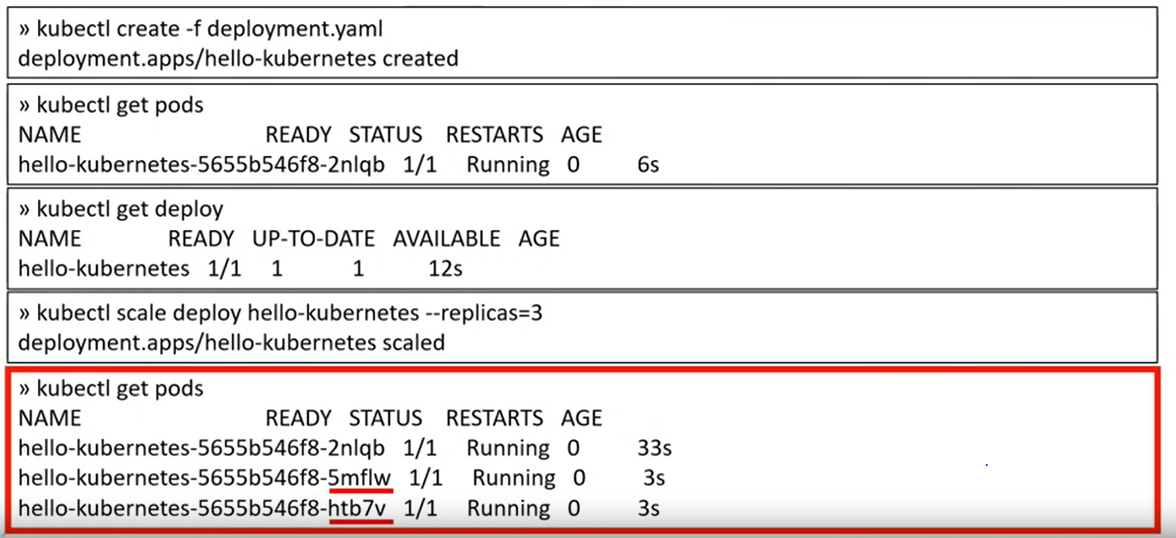

***ReplicaSet- How does it work?***

* *Believe that IKS is doing its job. But another way to check is to delete a pod and see what happens.*
* *Remember that we have a replica set that manages three pods. Lets list all pods and then delete.*
* *As you can see the pod ending with flw was deleted and the ReplicaSet immediately created a new pod ending in “w4r” to get the total number of pods back to three!!.*

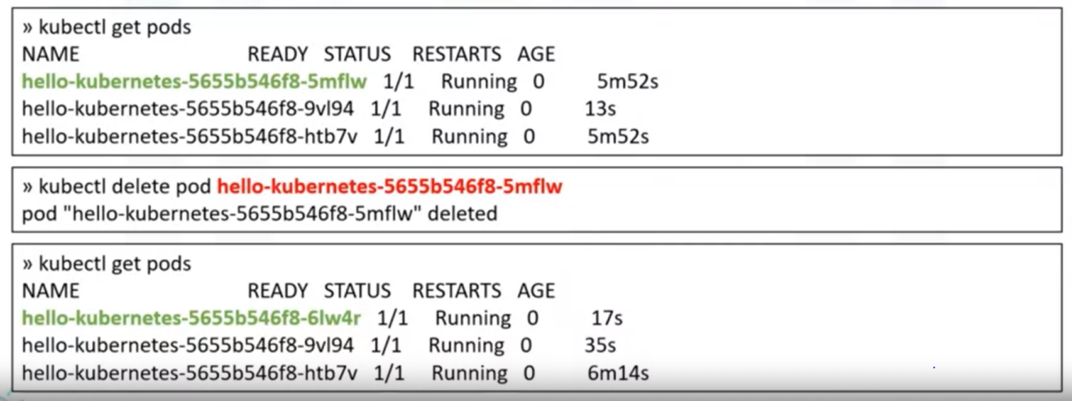

***Autoscaling:***

* *ReplicaSets provide a good start for scaling, but we don’t always want 10 instances of our resource running. We should be able to scale up as needed.*
* *Horizontal Pod Autoscaler or HPA enables the application to increase the number of pods based on the traffic.*
* *You can configure the desired state in HPA for example, the CPU and memory. The master node will periodically check pod metrics and scale to meet the desired state by updating the replicas field of the scaled resource, such as ReplicaSets or deployment.*
* *We start by getting current state of pod. We have one pod in our scenario. Having a ReplicaSet automatically created for us, since we created a deployment.*
* *Using the “autoscale” command with some attributes in order to autoscale. “min” is the number of minimum pods. “max” is the maximum number of pods. “cpu-percent” is the trigger to create new pods. This tells the system,”If the CPU usage hits 10% across the cluster, create a new pod”. We are using a very small number here because we don’t really have a CPU intensive application.*

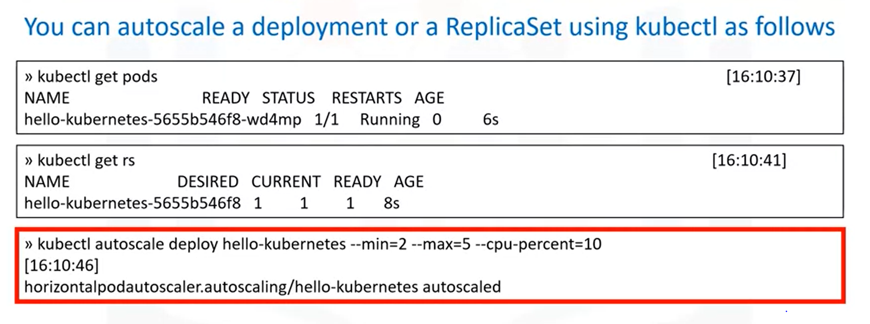

* *Behind the scenes, the deployment is still using the ReplicaSet to scale up and down.*
* *As you can see below, the number of replicas in the ReplicaSet or this autoscaled deployment has been set 2.*

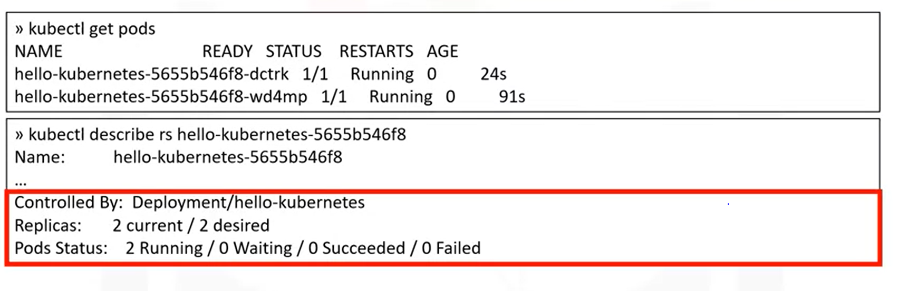

* *As noted before, a Horizontal Pod AutoScaler(HPA) is created behind the scenes to manage the autoscaling feature of the deployment.*

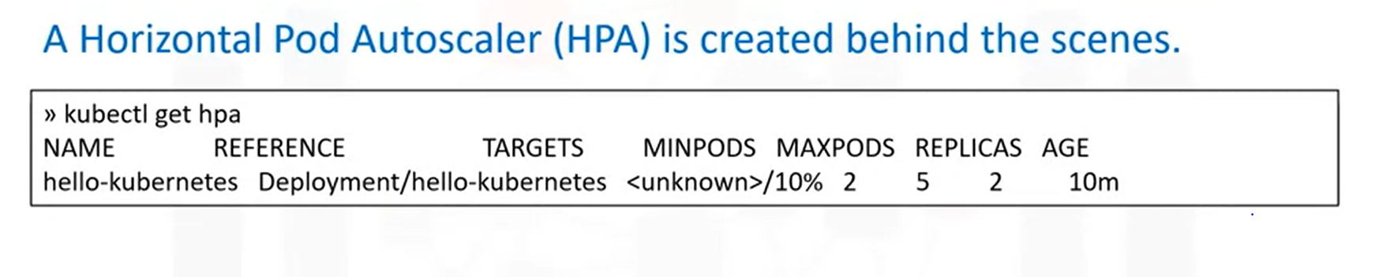

***Autoscaling from Scratch:***

* *You can create a standalone HPA using the following YAML, but we recommend using the “autoscale” command on the deploy/rs.*
* *You can set the min and max number of pods as you did with the “autoscale” command.*
* *The cpu-percentage flag displays as “targetCPUUtilizationPercentage”. This description would create the same autoscaler as we did before.*
* *Even though you can use this method, its simpler to use the autoscale command instead.*
* 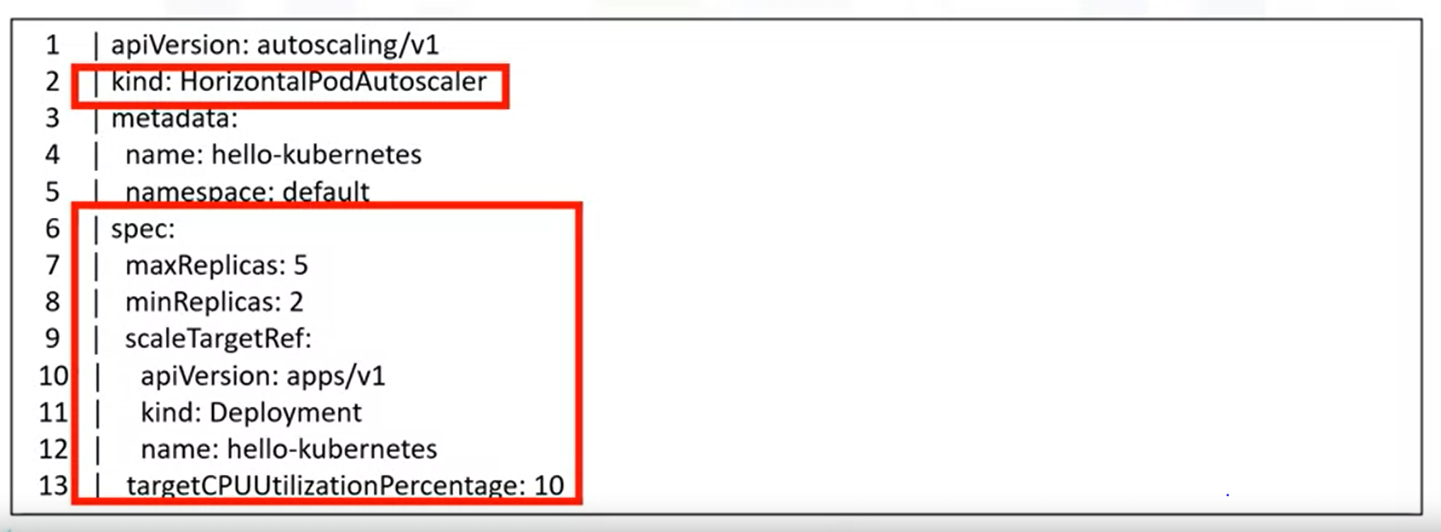

***Rolling Updates:***

* *Rolling updates are essential to any application running on a Kubernetes production environment.*
* *ReplicaSet and autoscaling are important to minimize downtime and service interruptions.*
* *Rolling Updates are a way to roll out app changes in an automated and controlled fashion throughout the pods.*
* *Rolling updates work with pod templates such as deployments.*
* *Rolling updates allow for rollback if something goes wrong.*

***Step-1:***

* *Add liveliness and readiness probes to your deployments. This ensures deployments are marked ready appropriately.*

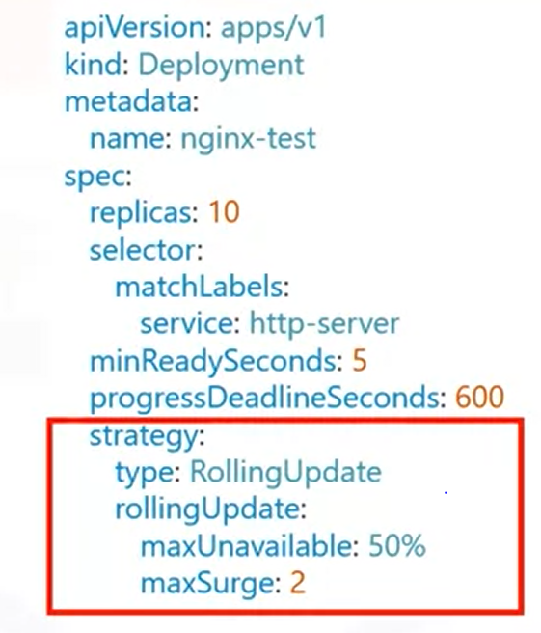

***Step-2:***

* *Here we are creating a deployment with 10 pods and our strategy states that we want at least 50% of the pods to always be available. The maxsurge of “2” says that there can only be 2 additional pods to the 10 we defined previously in order to finish the rollout.*
* *You can also set the maxUnavailable to “0” for a zero-downtime system.*
* *Setting the maxSurge to “100%” would essentially mean doubling the number of pods and creating a complete replica before taking the original set down after the rollout is complete.*
* *Sometimes its also useful to use the minReadySeconds attribute to wait a certain number of seconds before moving on to the next pod in the rollout stage.*
* *Working example of rolling out an update on our application.*

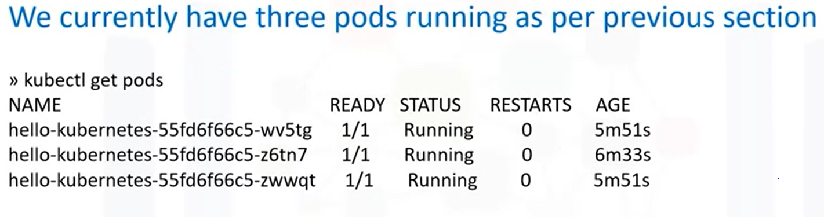

* *This is the original application that shows the text “Hello World”. We have created a deployment with three pods in our replicasets as shown above.*

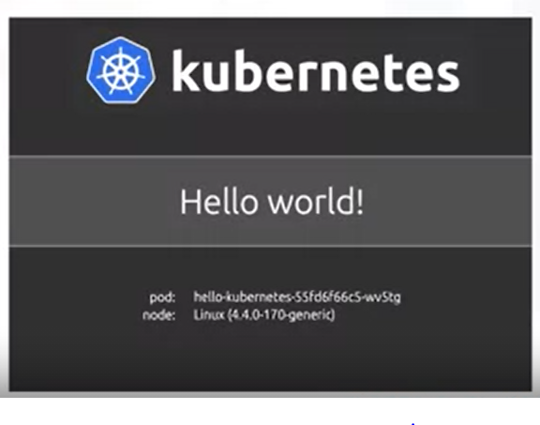

* *We have a new request from the client and we need to show “hello world v2!” to our users instead of the original text.*

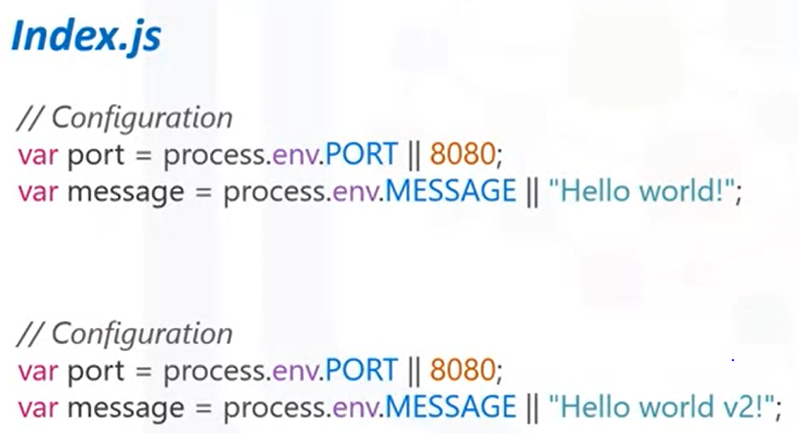

* *The catch is however that we cannot have any downtime in our application.*
* *Users must always be able to get to one version of the site while the rollout is happening in the background.*
* *As you can see, our new software has been dockerized and updated to new DockerHub with a tag of “Hello-kubernetes upkar/hello-kubernetes:2.0”. These are simple docker commands and not related to Kubernetes at all.*

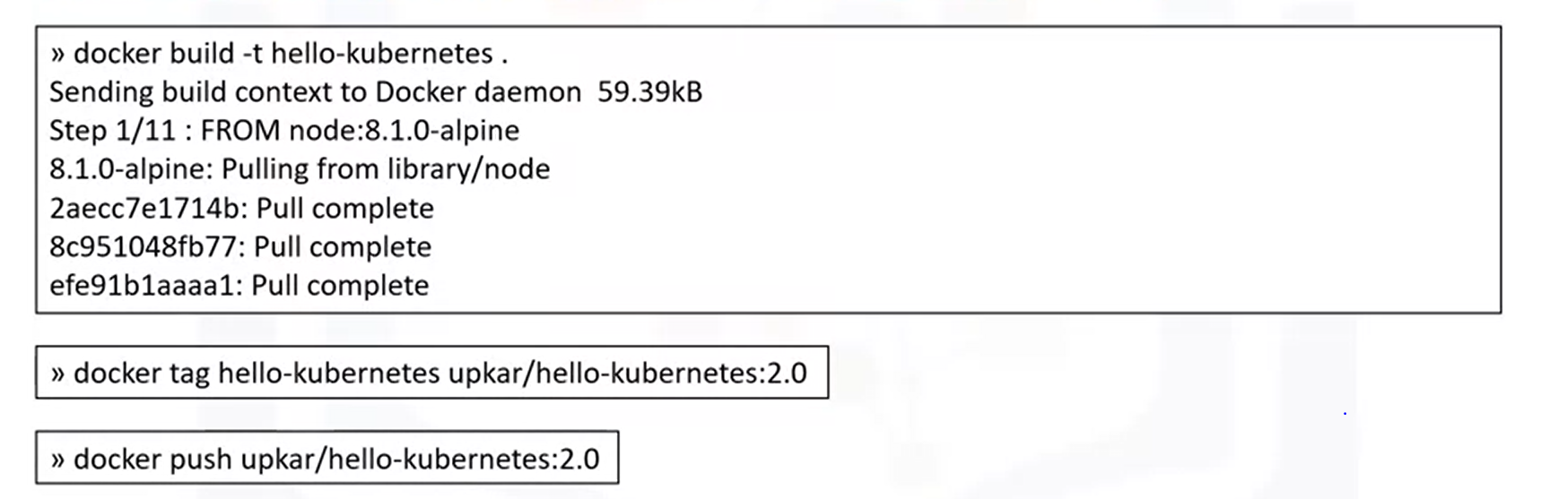

***Rolling Updates:***

* *We have three pods shown in the result with first command.*
* *The second command sets the image to the tagged image on DockerHub. We get a message saying that the image has been updated.*

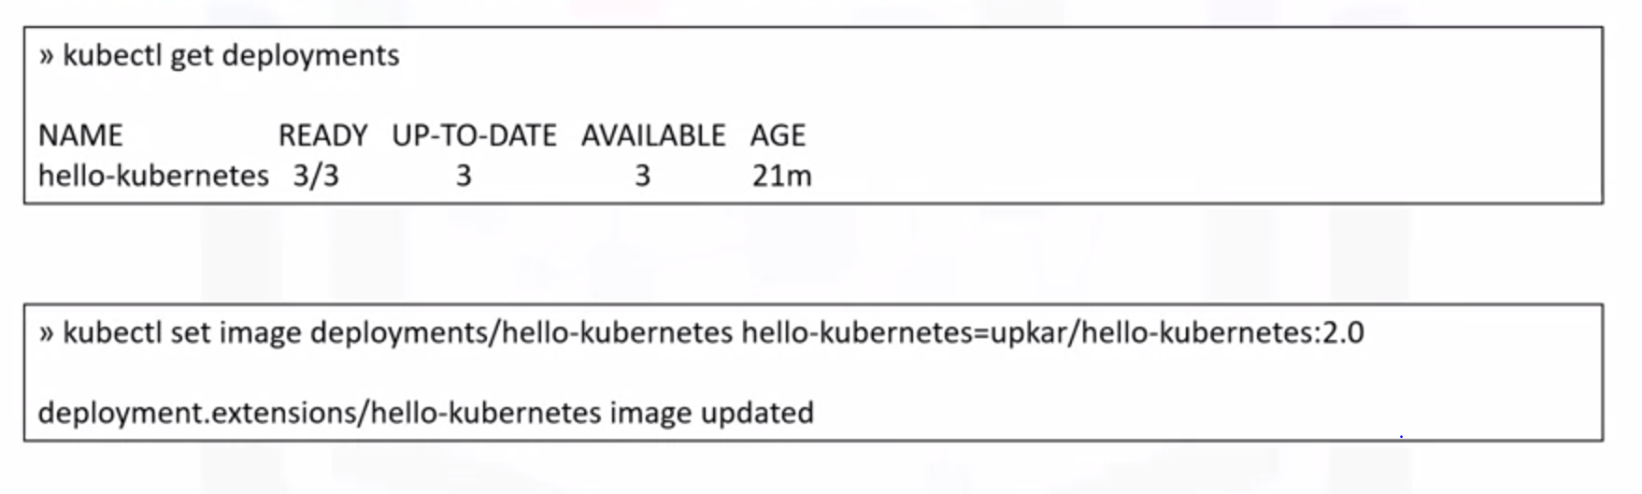

* *We can further check the status of the rollout using the “rollout status” command.*
* *As you can see in the first command, the API comes back with deployment “hello-kubernetes” successfully rolled out.*
* *If we go to the URL as before, you will see the new message “Hello world v2!”*

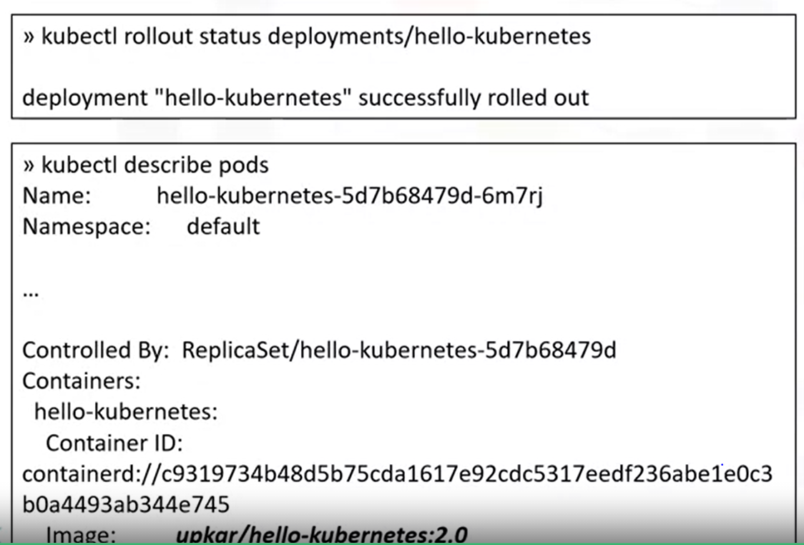

* *As happens sometimes, the client has now changed their mind and they would like the application to show the original messages again.*
* *You can undo the rollout as shown below in the first command. The second command shows that the original pods after the rollout are being terminated.*

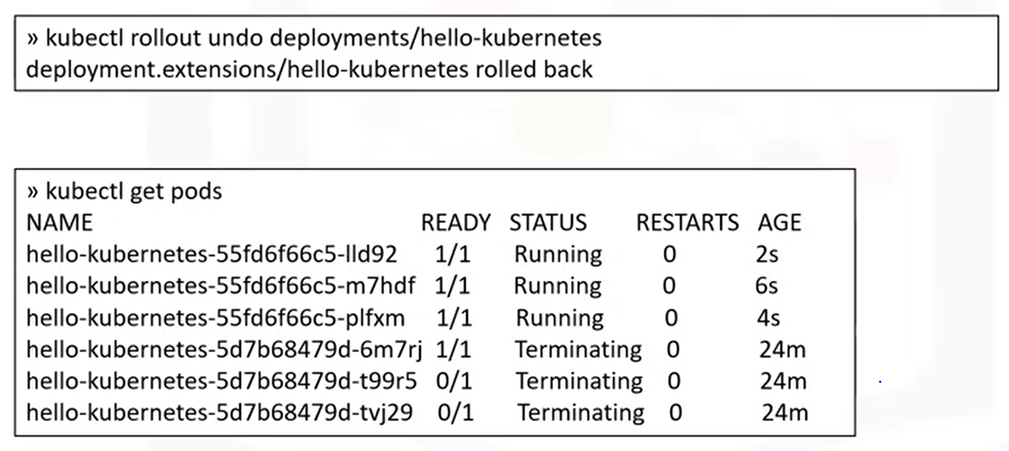

* *And we have three new pods that were created as part of this rollback.*
* *So, in this section, we saw how to rollout changes to your application and also how to rollback any changes that are not needed anymore or were made by mistake.*

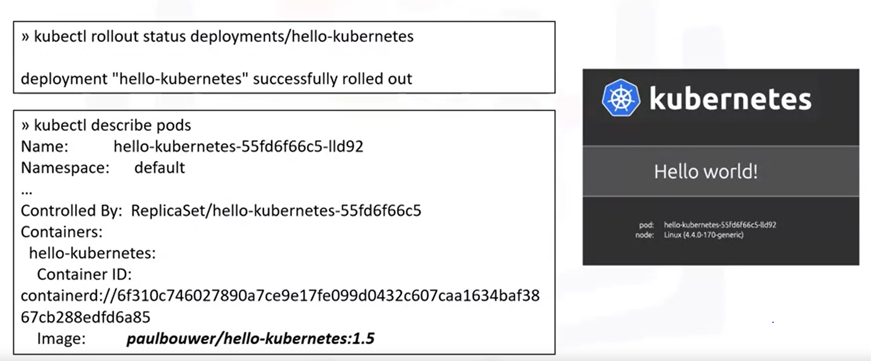

* *To summarize, rolling updates give us a way to publish changes to our applications without noticeable interruptions for the user.*
* *Additionally, rolling updates give us a way to roll back any changes so that application can revert to stable state in the event of errors.*

***ConfigMaps and Secrets:***

* *As software developers, we know, not to hardcode configuration variables in code.*
* *We keep them separate so that any changes in configuration donot require code changes.*
* *Examples of these variables can include non-sensitive information like environments for example dev, test and prod or sensitive information such as API keys and accountId’s*
* *Configuration: Current State:*
* *We have two variables in the code that have been given default values. There are hard-coded values 8080 and “Hello-world”.*
* *They will be overwritten by the environment variable process “process.env.PORT” and “process.env.MESSAGE” if the environment variables are present.*
* *Lets pass in the MESSAGE value from a ConfigMap and overwrite the “Hello World!” string.*
* *The string appears on the index page as you can see in below screenshot.*

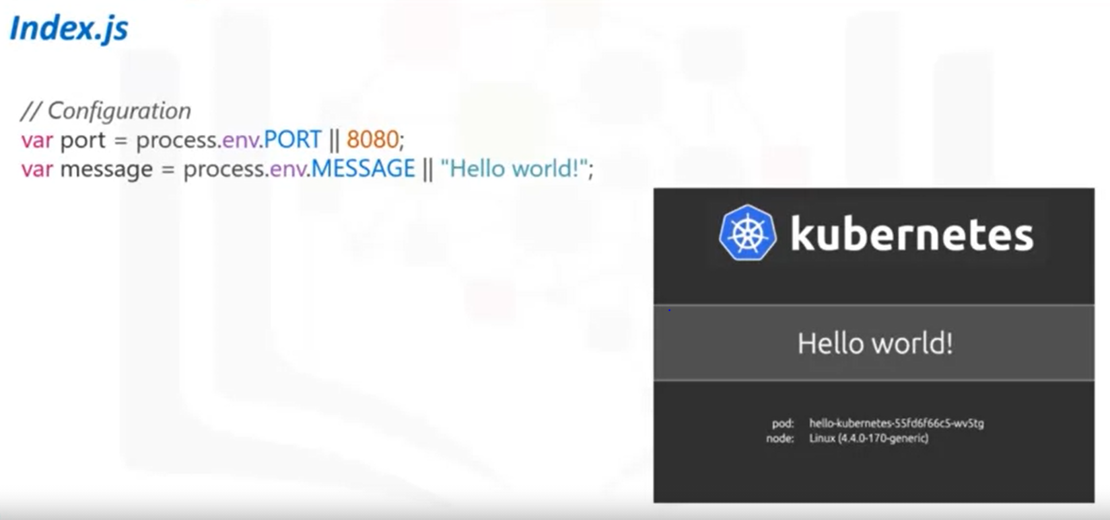

* *ConfigMaps give us a way to provide configuration data to pods and deployments so we don’t have to hard-code that data in the application code.*
* *You can also reuse these ConfigMaps and Secrets for multiple deployments thereby decoupling the environment from the deployment themselves.*
* *Secrets work similarly to ConfigMaps but are meant for sensitive information.*
* *ConfigMaps can be created in a couple of different ways:*

1. *Using String literals*
2. *Using an existing properties or “key”=”value” file*
3. *Providing a ConfigMap YAML descriptor file both the first and second methods can help us create such a YAML file.*

* *The deployment or pods can then consume a ConfigMap by using environment variables the “configMapKeyRef” attribute or mounting a file using the volumes plugin.*
* *The ConfigMap and the Secret are applied to the pod or the deployment just before they are run.*
* *We can potentially supply the environment variable directly in the YAML file.*

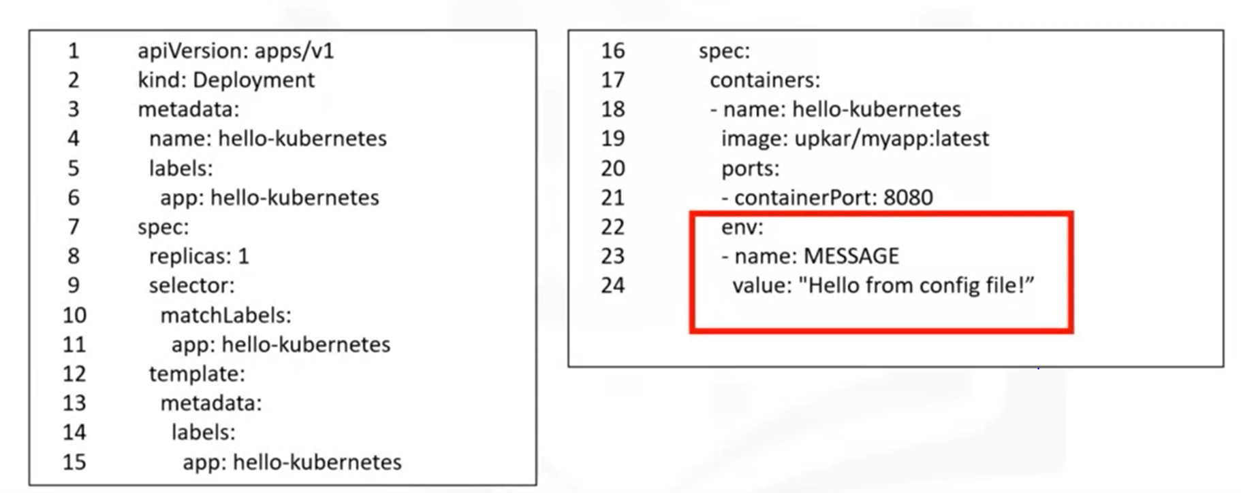

* *The MESSAGE variable can now be used in the Javascript file as “process.env.MESSAGE”.*
* *In fact, if you applied this deployment descriptor to your deployment and viewed this application you would see the new message as shown.*

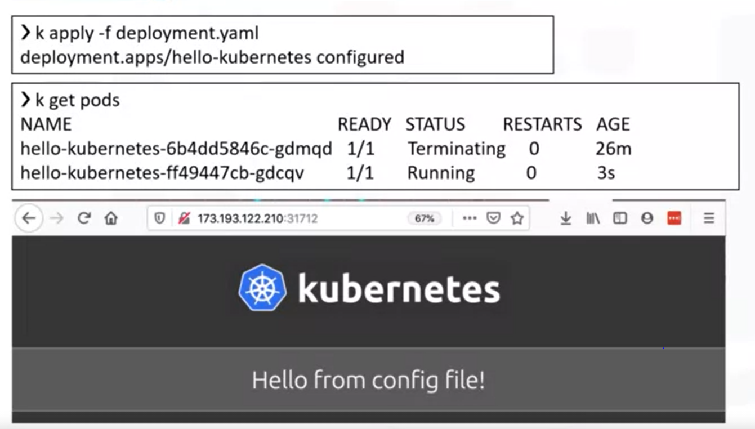

* *Now, the string Hello from config file” is hard-coded to our deployment in the descriptor file.*
* *The simplest way to provide a ConfigMap is to provide a key-value pair in the “create*
* *configmap command.*
* *Next, you need to tell your deployment about this new variable and where to pick it up.*
* *You do that by adding an “env” section in the deployment descriptor as shown here and using the “valueFrom” attribute to point to the configMap created in the first step.*

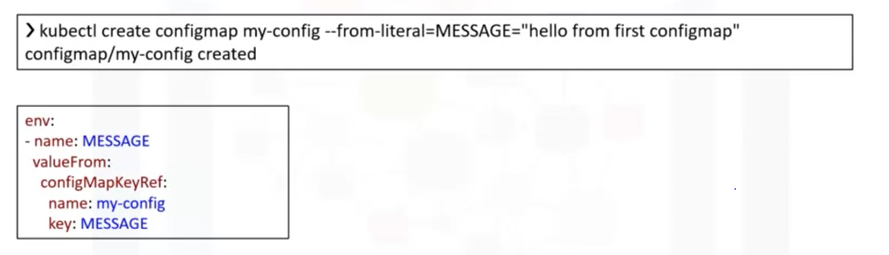

* *In this case, the deployment will look for a key called “MESSAGE” in the ConfigMap named “my-config”.*
* *You can list all the ConfigMaps in your cluster using the “kubectl get configMaps” command and describing the ConfigMap will give us the descriptor for the ConfigMap.*
* *You can see the “env” section from deployment descriptor on the right of the slide.*

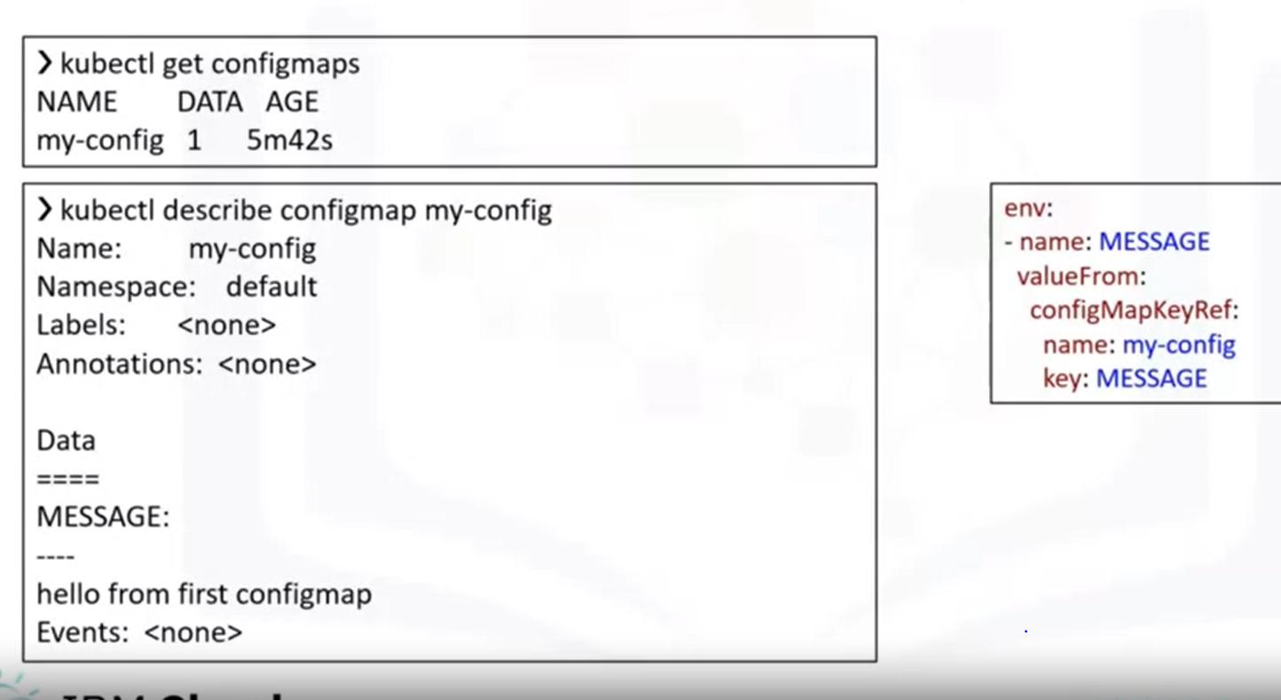

* *Another way to add the “MESSAGE” variable in the ConfigMap is to use a file.*
* *This file will contain all environment variables in the “key=value” format.*

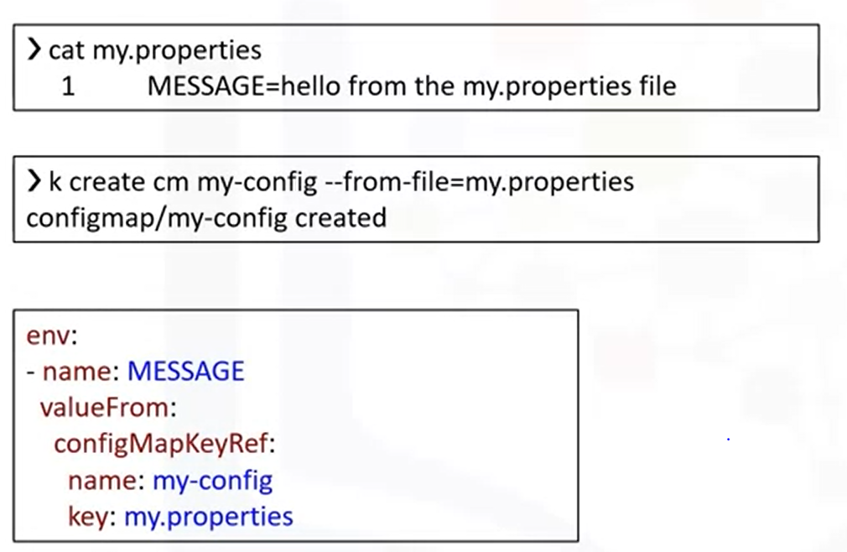

* *This file is useful for adding a large number of variables at the same time instead of listing them on the command line.*
* *The file is shown above. It has the one MESSAGE key with the string “MESSAGE=hello” from the my.properties file as the value.*
* *We can now create the ConfigMap by using the “—from-file” flag.*
* *Notice that the deployment descriptor section also looks a bit different.*
* *The key is now “my.properties” and everything inside the file will appear as subkeys in the environment variable.*
* *To use it in the server.js file you would refer to it as “process.env.MESSAGE.MESSAGE”. If you give a directory to the “—from-file” flag, all files in the directory will be loaded into the Secret ConfigMap.*
* *You can also load the file under a specific key by using the “—from-file=key=filename” format.*
* *As with the first method, you can describe the deployment descriptor to get the YAML output as shown here.*
* *Again, we have listed the “env” section from the deployment descriptor on the right of the screen.*
* *Finally, if you already have a YAML file with the ConfigMap descriptor, you can simply apply that file.*
* *In our case, we have saved the output “kubectl get configmap” as a YAML file called “my-config.yaml”.*
* *As you can see from the first command, there is currently no ConfigMap*

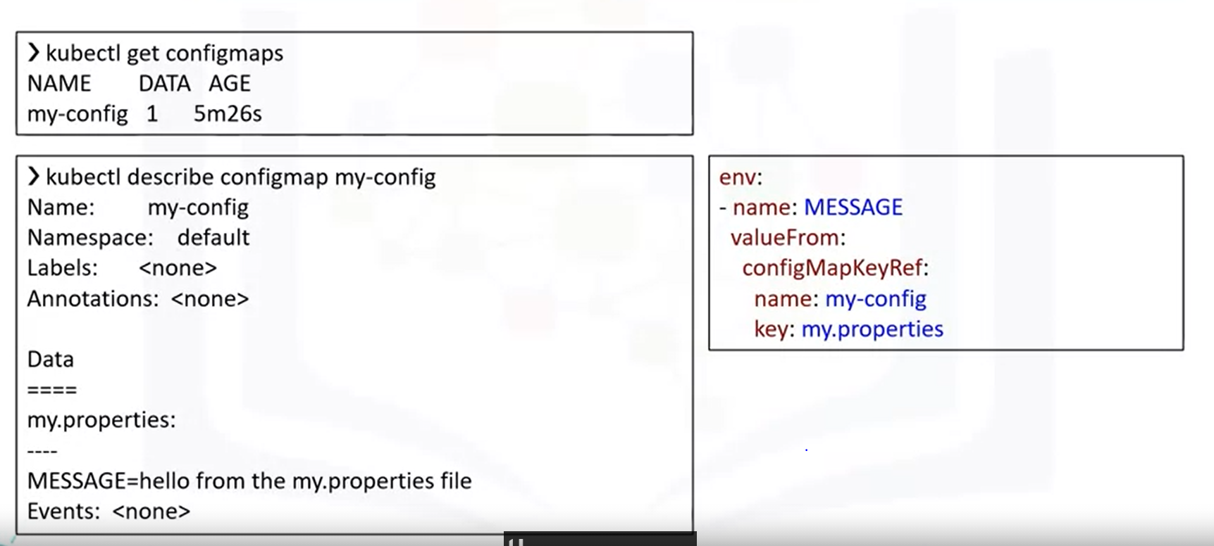

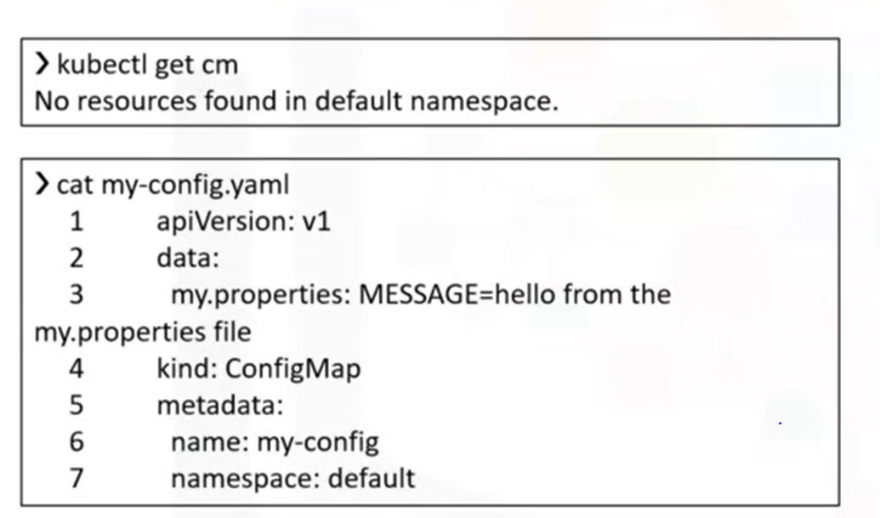

* *This will create our ConfigMap as shown here. The application should work as before.*

***Secrets: create:***

* *Working with secrets is similar to working with ConfigMaps.*
* *First, we create a secret using a string literal.*
* *Next, we use the “get” command to see that the Secret was created.*
* *Finally, to prove that our Secret is actually a secret, we can use the “describe” command to see that the Secret is not printed out in the plain text in the CLI.*
* *In fact, if we print out the Secret in YAML format using kubectl, you can see that the encoded value is printed out to the console.*

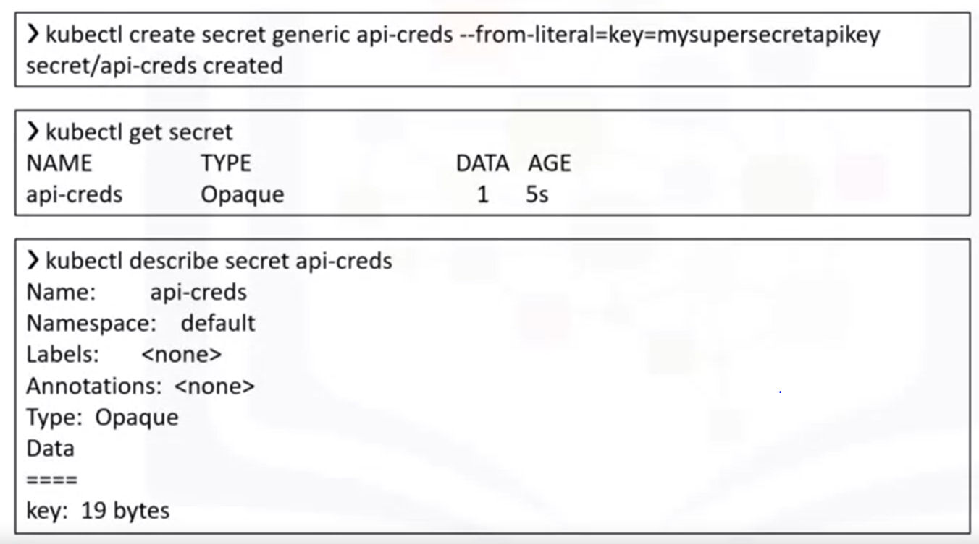

* *To use our Secret, let’s add another “env” to the deployment descriptor as shown here.*
* *We can now use the key as usual in our application by referring to it as “process.env.API CREDS”.*
* *I have changed the code to print out all environment variables in the Node.js file.*
* *You can see the printed Secret here. Another way to use the Secret key in our application is to use volume mounts.*
* *We first create the same Secret we had previously. Next in the descriptor YAML file, we need to have a volume for the Secret with a corresponding volume mount.*
* *Each container in the descriptor file will have its own volume mount but can share the volume itself.*
* *In this case, our “api-creds” Secret will be mounted as a file at “/etc/api/api-creds”.*
* *The program that needs this Secret will have to read and process the file to extract the Secret.*

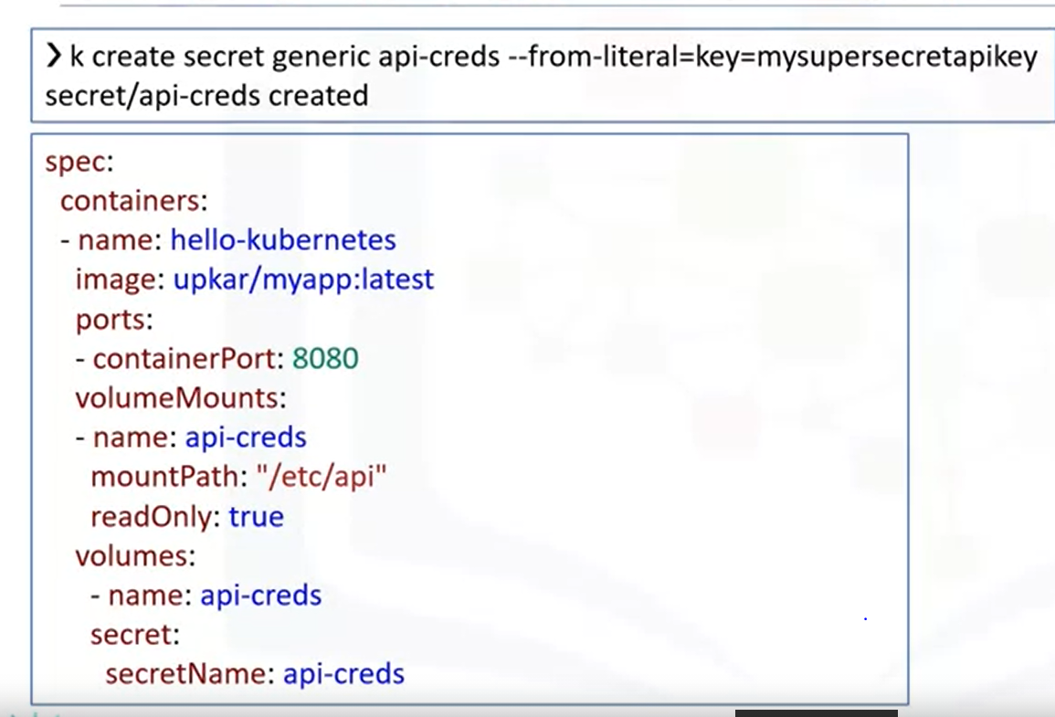

* 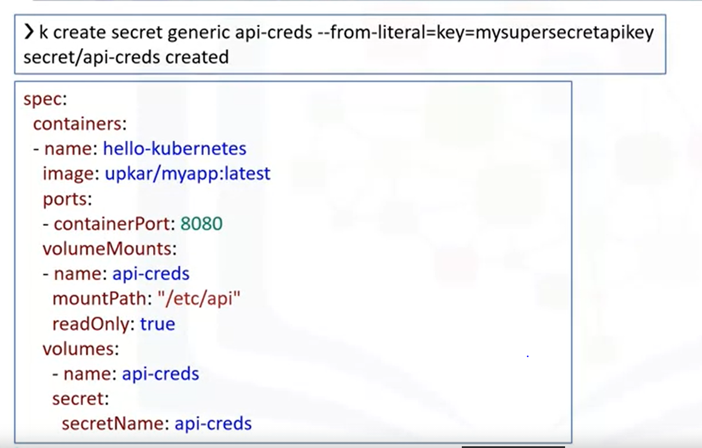

***Service Binding:***

* *One way to do that in Kubernetes is to bind the external service to our deployment.*
* *In this section, we will bind the Watson Tone Analyzer service to our application.*
* *Service Binding enables you to bind an IBM Cloud service instance to Kubernetes cluster.*
* *The service credentials are available as Secrets to any application deployed on the cluster.*
* *By mounting the Kubernetes Secret as a volume to your deployment, you make the IBM Cloud Identity and Access Management(IAM) API key available to the container that runs in your pod.*
* *A JSON file called “binding” is created in the volume mount directory.*
* *You can see different services provided on IBM cloud in the catalog.*
* *They range from visual recognition to natural language processing and creating chatboxes.*
* *We are going to use the Tone Analyzer service to explain binding. This service uses linguistic analysis to detect tone in a given text. The service provides an SDK in Javascript.*
* *To use this service, we will bind it to our deployment so that credentials are made available to us automatically.*
* *The code will then use the credentials form the binding and call the Tone Analyzer service.*

***Create a Service Binding:***

* *In the first step, we are creating the service using CLI.*
* *Step1: Create service using IBM Cloud UI or CLI.*

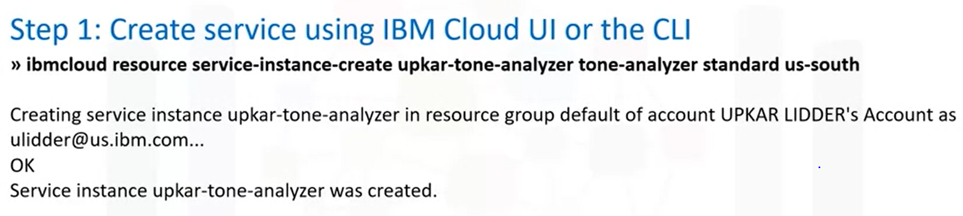

* *You can also use the catalog on the IBM Cloud website to create the service.*
* *In the second step, we are binding this newly created service to our cluster by using the “service bind” command.*

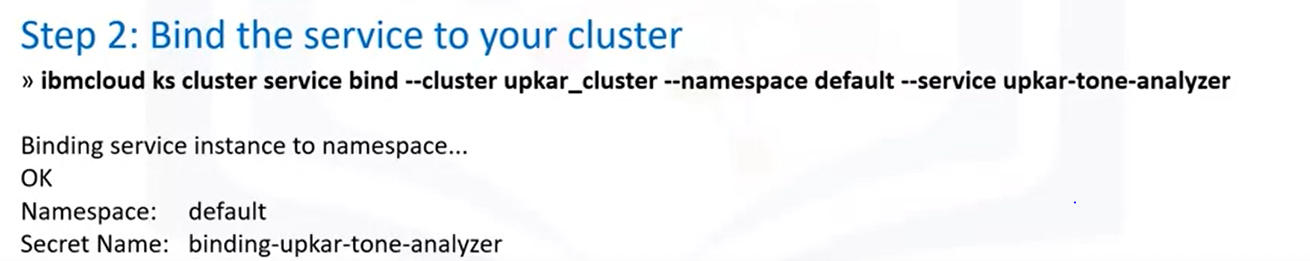

* *Once you bound a service to the cluster, you will get access to the service credentials in the Secrets object. The command shows how to retrieve all the secrets in your Kubernetes cluster.*
* *You can view the same secret in the Kubernetes dashboard on IBM Cloud Kubernetes service.*
* *Once you have bound a service to your cluster, the service secrets are made available with the environment variables as shown.*

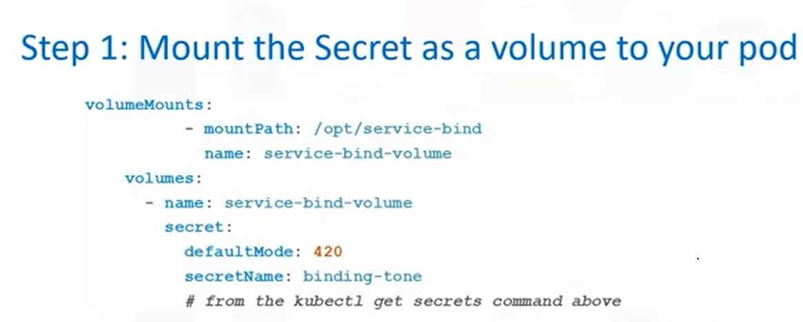

* *The binding.apikey, binding.username and binding.password correspond to the apikey, username and password of the Watson Tone Analyzer service instance created in the previous step.*

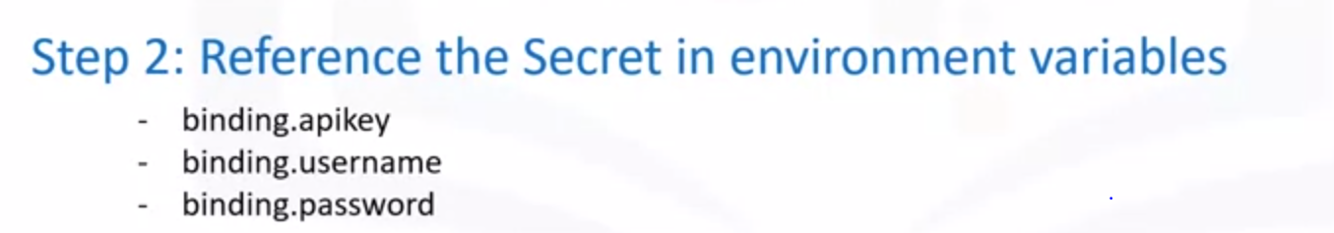

* *The below slide shows a sample Node.js application using the binding.apikey, binding.username and binding.password environment variable inside an Express.js application that will be deployed to IBM Cloud Kubernetes service.*

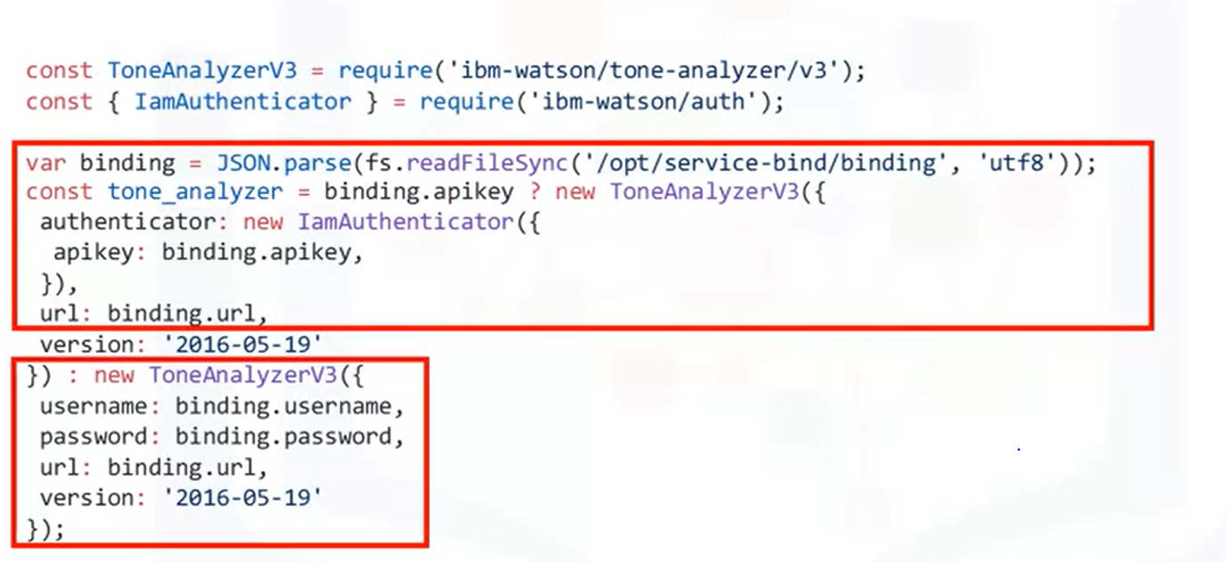

***Scaling and Updating applications:***

* *Open terminal*
* *Change to your project folder. cd /home/project*
* *Clone the git repository that contains the artifacts. [ ! -d 'CC201' ] && git clone* [*https://github.com/ibm-developer-skills-network/CC201.git*](https://github.com/ibm-developer-skills-network/CC201.git)
* *Change to the directory of the project. cd CC201/labs/3_K8sScaleAndUpdate/*
* *List the contents and directories of the lab. Ls*
* *Export your namespace as an environment variable so that it can be used in subsequent commands. export MY_NAMESPACE=sn-labs-$USERNAME*
* *Use the explorer to view the dockerfile we will use to build the image.*
* *Build and push the image again, as it may have been deleted automatically. docker build -t us.icr.io/$MY_NAMESPACE/hello-world:1 . && docker push us.icr.io/$MY_NAMESPACE/hello-world:1*
* *Use the explorer to edit deployment.yaml in this directory. The path of this file is  CC201/labs/3_K8sScaleAndUpdate/. You need to insert your namespace where it says <my_namespace>.*
* *Run your image as deployment. kubectl apply -f deployment.yaml*
* *List pods until the status is Running. kubectl get pods*
* *In order to access the application, we have to expose it to the internet via a Kubernetes service. kubectl expose deployment/hello-world*
* *This creates a service of type ClusterIP. Open a new terminal window. Terminal> New Terminal*
* *Cluster IP’s are only accessible within the cluster. To make this externally accessible, we will create a proxy. Note that this is not how you would make an application externally accessible in a production scenario. Run this command in new terminal window since your environment variables need to be accessible in the original window for subsequent commands.* ***Kubectl proxy***
* *This command doesn’t terminate until you terminate it. Keep running so that you can continue accessing the app.*
* *In the original terminal, ping the application to get a response. curl -L localhost:8001/api/v1/namespaces/sn-labs-$USERNAME/services/hello-world/proxy*
* *In real world applications, load on an application can vary over time. If our application begins experiencing heightend load, we want to scale it up to accommodate that load. There is a simple kubectl command for scaling.*
* *Use the scale command to scale up your deployment. Make sure to run this in the terminal window that is not running the proxy command. kubectl scale deployment hello-world --replicas=3*
* *Get pods to ensure that there are now three pods instead of just one. In addition, the status should eventually update to “Running” for all three. kubectl get pods*
* *Ping your application multiple times to ensure that Kubernetes is load-balancing across the replicas. for i in `seq 10`; do curl -L localhost:8001/api/v1/namespaces/sn-labs-$USERNAME/services/hello-world/proxy; done*
* *Similarly, you can use the scale command to scale down your deployment. kubectl scale deployment hello-world --replicas=1*
* *Check the pods to see that two are deleted or being deleted. kubectl get pods*

***Performing Rolling updates:***

* *Rolling updates are an easy way to update our application in an automated and controlled fashion. To simulate an update, lets first build a new version of our application and push it to Container Registry.*
* *Use the explorer to edit app.js. The path to this file is CC201/labs/3_K8sScaleAndUpdate/. Change the welcome message from 'Hello world from ' + hostname + '! Your app is up and running!\n' to 'Welcome to ' + hostname + '! Your app is up and running!\n'. Make sure to save the file when you're done.*
* *Build and push this new version to Container Registry. Update the tag to indicate that this is a second version of this application. Make sure to use the window that isn't running the proxy command. docker build -t us.icr.io/$MY_NAMESPACE/hello-world:2 . && docker push us.icr.io/$MY_NAMESPACE/hello-world:2*
* *List images in Container Registry to see all the different versions of this application that you have pushed so far. ibmcloud cr images*
* *Update the deployment to use this version instead. kubectl set image deployment/hello-world hello-world=us.icr.io/$MY_NAMESPACE/hello-world:2*
* *Get a status of the rolling update by using the following command: kubectl rollout status deployment/hello-world*
* *You should see an output like this, indicating that the rollout succeeded: deployment "hello-world" successfully rolled out.*
* *You can also get the Deployment with the wide option to see that the new tag is used for the image. kubectl get deployments -o wide. Look for the IMAGES column and ensure that the tag is 2.*
* *Ping your application to ensure that the new welcome message is displayed.*
* *curl -L localhost:8001/api/v1/namespaces/sn-labs-$USERNAME/services/hello-world/proxy*
* *It's possible that a new version of an application contains a bug. In that case, Kubernetes can roll back the Deployment like this:*
* *kubectl rollout undo deployment/hello-world*
* *Get a status of the rolling update by using the following command:*
* *kubectl rollout status deployment/hello-world*
* *Get the Deployment with the wide option to see that the old tag is used*
* *kubectl get deployments -o wide*
* *Look for the IMAGES column and ensure that the tag is 1.*

***Using a ConfigMap to store configuration****:*

* *ConfigMaps and Secrets are used to store configuration information separate from the code so that nothing is hardcoded. It also lets the application pick up configuration changes without needing to be redeployed. To demonstrate this, we'll store the application's message in a ConfigMap so that the message can be updated simply by updating the ConfigMap.*
* *Create a ConfigMap that contains a new message.*
* *kubectl create configmap app-config --from-literal=MESSAGE="This message came from a ConfigMap!"*
* *Use the Explorer to edit deployment-configmap-env-var.yaml. The path to this file is CC201/labs/3_K8sScaleAndUpdate/. You need to insert your namespace where it says <my_namespace>. Make sure to save the file when you're done.*
* *In the same file, notice the section reproduced below. The bottom portion indicates that environment variables should be defined in the container from the data in a ConfigMap named app-config.*

*containers:*

*- name: hello-world*

*image: us.icr.io/<my_namespace>/hello-world:3*

*ports:*

*- containerPort: 8080*

*envFrom:*

*- configMapRef:*

*name: app-config*

* *Use the Explorer to open the app.js file. The path to this file is CC201/labs/3_K8sScaleAndUpdate/. Find the line that says, res.send('Hello world from ' + hostname + '! Your app is up and running!\n'). Edit this line to look like the following:*
* *res.send(process.env.MESSAGE + '\n')*
* *Make sure to save the file when you're done. This change indicates that requests to the app will return the environment variable MESSAGE.*
* *Build and push a new image that contains your new application code.*
* *docker build -t us.icr.io/$MY_NAMESPACE/hello-world:3 . && docker push us.icr.io/$MY_NAMESPACE/hello-world:3*
* *The deployment-configmap-env-var.yaml file is already configured to use the tag 3.*
* *Apply the new Deployment configuration.*
* *kubectl apply -f deployment-configmap-env-var.yaml*
* *Ping your application again to see if the message from the environment variable is returned.*
* *curl -L localhost:8001/api/v1/namespaces/sn-labs-$USERNAME/services/hello-world/proxy*
* *If you see the message, "This message came from a ConfigMap!", then great job!*
* *Because the configuration is separate from the code, the message can be changed without rebuilding the image. Using the following command, delete the old ConfigMap and create a new one with the same name but a different message.*
* *kubectl delete configmap app-config && kubectl create configmap app-config --from-literal=MESSAGE="This message is different, and you didn't have to rebuild the image!"*
* *Restart the Deployment so that the containers restart. This is necessary since the environment variables are set at start time.*
* *kubectl rollout restart deployment hello-world*
* *Ping your application again to see if the new message from the environment variable is returned.*
* *curl -L localhost:8001/api/v1/namespaces/sn-labs-$USERNAME/services/hello-world/proxy*
* *Delete the Deployment.*
* *kubectl delete -f deployment-configmap-env-var.yaml*
* *Delete the Service.*
* *kubectl delete service hello-world*
* *Return to the terminal window running the proxy command and kill it using Ctrl+C.*

***What Is Kubernetes:***

* *Kubernetes is a portable, extensible, open-source platform for managing containerized workloads and services that facilitates both declarative configuration and automation.*
* *It has a large, rapidly growing ecosystem. Kubernetes services, support, and tools are widely available*
* *Note that in addition to listing characterizations and features of Kubernetes itself, the documentation also highlights that there is a large growing ecosystem around Kubernetes.*
* *This point is not made in passing, this is a significant fact that makes Kubernetes even more appealing, in addition to all features we have covered so far.*
* *Recall that Kubernetes isn’t an all-inclusive platform as a service that provides a lot of services out of the box.*
* *Instead, a decision was made to facilitate developer choice and provide a more flexible model, rather than a more opinionated one.*
* *This is where the Kubernetes ecosystem step in to help. Running a containerized application requires more than orchestration tool used for the running containers.*
* *Separate tools are needed along the way for variety of tasks.*
* *For instance, we built container images using Docker commands and pushed those images to a container registry.*
* *These are two examples of the Kubernetes ecosystem tools like Docker that help build container images and registries that host those images.*
* *But there’s also observability like logging and monitoring, continuous integration and continuous delivery and many more ecosystem features and resources.*
* *The Cloud native Computing Foundation, which hosts Kubernetes provides a couple of resources to better understand both cloud-native development, consequently the Kubernetes ecosystem.*
* *The below image illustrates what CNCF calls the cloud-native trail map and shows the different steps for cloud native development.*
* *Users can choose an open source project at each step, including Containerization, CI/CD, Orchestration & Application Development which is the only step that includes Kubernetes as solution, Observability and analysis.*
* *The other 9 steps require other tools. We have included this image to demonstrate first that there are many stages to cloud-native development other than container orchestration and second most of these stages require other tools.*
* *As a result, a large and growing Kubernetes ecosystem is needed.*
* *The trail map can be found in the CNCF’s trailmap GitHub repo.*
* *The Cloud Native Interactive landscape is another resource provided by CNCF.*
* *This can be found at landscape.cncf.io*
* 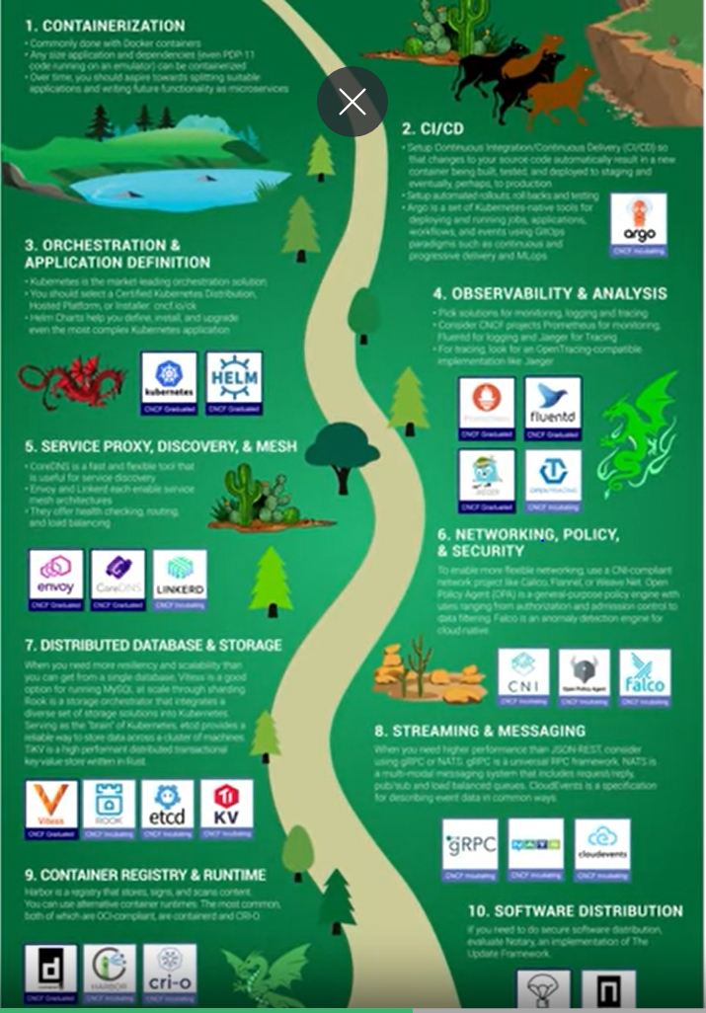
* *This detailed image will be difficult to read. This landscape shows all sorts of proprietary and open source tools available for cloud-native development.*
* *In addition to Kubernetes, CNCF hosts several other projects, many of which fall squarely in the Kubernetes ecosystem.*
* *But there are also different projects out there that can be used well with Kubernetes. As Kubernetes continues to establish itself the de facto choice for container orchestration.*
* *Cloud-native tools pick up on this trend and develop their capabilities to work well with Kubernetes.*
* *So even though Kubernetes doesn’t provide the same tools that an all-inclusive Paas would, the current needs for cloud-native development are being addressed by tools in the Kubernetes ecosystem, providing greater developer choice rather than a mandated approach and as needs grow, the ecosystem grows in response.*

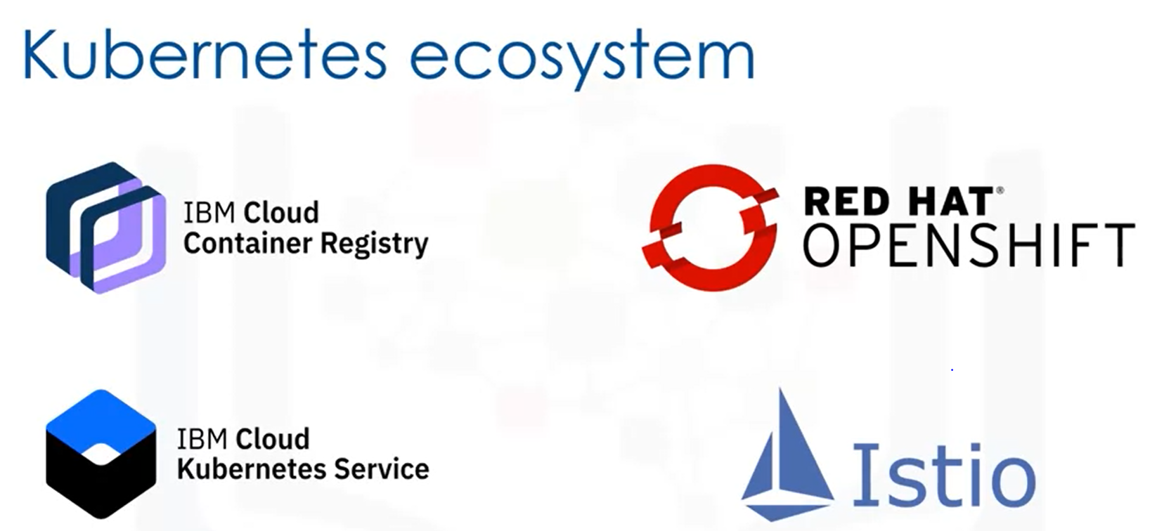

***Introduction to Redhat Openshift:***

* *The Red Hat website defines Openshift as a hybrid cloud, enterprise Kubernetes application platform.*
* *Hybrid Cloud is an IT architecture that incorporates workload portability, orchestration and management across on-premises and cloud environments.*
* *Openshift can be run on-prem and in cloud environments. Openshift builds an open-source Kubernetes to create an application platform.*
* *As an application platform, Openshift does more than orchestrate containers- it also provides additional tooling around the complete lifecycle of applications, from build and CI/CD to monitoring and logging.*
* *Kubernetes is an important component in Openshift which makes Openshift different from other tools in the Kubernetes ecosystem.*
* *Openshift isn’t a tool to be used with Kubernetes like a logging tool or a container registry.*
* *Rather, it is an extension of Kubernetes. It builds on Open source Kubernetes to provide a more robust platform for applications.*
* *This platform includes more than orchestration. It includes logging, monitoring, container registry and much more.*
* *In an openshift environment, the Kubernetes control plane runs on Red Hat Enterprise Linux CoreOS, while the worker nodes support Red Hat Enterprise Linux.*
* *Next is Kubernetes. As we have already mentioned, Kubernetes is an integral part of Openshift but its only one piece of puzzle.*
* *So far, this architecture is similar to Kubernetes. We have infrastructure with Kubernetes deployed on top.*
* *But then comes the cluster services. Note that these services include integrated monitoring, a private registry deployed within the cluster, networking solutions and many other services that are not provided by Kubernetes.*
* *This makes for a helpful and intuitive user experience built on top of Kubernetes.*
* *There are several additional services provided by OpenShift. First are platform services. These include a service mesh, CI/CD pipelines and full stack logging.*
* *These platform services help manage workloads running in OpenShift.*
* *Next are application services. OpenShift provides images for running databases, and it includes support for variety of languages and runtimes.*
* *These application services help users build cloud-native apps. Finally, developer services include a CLI, as well as plugins and extensions for IDEs with which to develop your applications.*
* *These services boost developer productivity. We have mentioned that many tools in the Kubernetes ecosystem are open source software.*
* *OpenShift is an open source but there is some nuance to understand.*
* ***Origin Kubernetes Distribution*** *or OKD is the upstream Kubernetes distribution that is embedded in openshift.*
* *As we discussed, it adds developer and operations-centric tooling on top of the Kubernetes and like any other open source software, it can be used by anyone for free.*
* *We can make an analogy to the Linux Kernel. Kubernetes is like the Linux kernel in that the same Kubernetes can they run in a variety of distributions that support various developers needs.*
* *OpenShift is therefore a specific Kubernetes distribution that caters to a set of needs. So how does OKD relate to OpenShift?*
* *RedHat packages OKD with other software, resources and official support to create a product, RedHat OpenShift Container Platform, that it then sells.*
* *So, while OKS is open source and freely available, OpenShift is a product with official support and some additional software from RedHat.*

***RedHat Openshift and Kubernetes:***

***Similarities:***

* *Native Kubernetes capabilities are also present in OpenShift. This means that OpenShift includes just about everything provided by Kubernetes as well as additional functionality.*
* *Both are container orchestration tools and both are open source software.*

***Differences:***

* *First, Openshift is a product, while Kubernetes is a project.*
* *Many companies have monetized Kubernetes in various ways but at the core, it is an open source project. OpenShift, however is a product developed and supported by RedHat, though the underlying components are also open source software.*
* *We learned about kubectl but OpenShift has its own CLI called “oc”.*
* *The oc CLI includes a copy of kubectl, so you can still run kubectl commands with oc.*
* *However, oc also includes additional OpenShift- specific objects and functionality.*
* *OpenShift comes with a web UI for performing developer and operations.*
* *While Kubernetes does have a dashboard, it is installed separately and it’s not as integral as the console is to OpenShift.*
* *While Kubernetes Deployment objects are still present in OpenShift, DeploymentConfig objects are OpenShift specific.*
* *These objects are based on an older Kubernetes object called ReplicationController instead of ReplicaSets.*
* *One advantage of DeploymentConfig objects is that they include triggers that drive automated deployments in response to events.*
* *This enables the buildsvcapabilities present in OpenShift.*

***Deploying an application in Kubernetes:***

* *So, deploying an application in Kubernetes can actually be a little bit time consuming.*
* *So, first lets assume that you have your code up on something like GitHub, so you will pull that code to your local machine, may be set up a container.*
* *Once you got that container you will have to figure out where you want to actually host it. So the registry so may be you want to use something like DockerHub or you want a private registry.*
* *One thing I want to mention, if you take advantage of Manage Kubernetes so like Kubernetes from your favorite cloud provider, generally they have options to have a registry or a private registry directly in that experience.*
* *Next, once its on the registry and this is one of the things that gets complicated because there is so many different options for deploying your applications.*
* *On the Openshift side of things on the other hand they have an opinionated approach, so all you really have to do is create an application and a project at which point OpenShift does the heavylifting on the backend so its going to create those pipelines it’s going to create all of that automation that you need to do things like dev, test and prod for your applications.*
* *So really it makes it a lot easier and you can get started maybe using something like their Jenkins approach or source to image capabilities.*
* *We have more advantage on Kubernetes side of things. As you don’t have an opinionated prescribed way of doing this., so power users and teams that are kind of influenced by legacy architectures, Kubernetes might be more effective. For teams that really just want to be told how to get everything done and have a streamlined approach for their devops and pipeline approach the Openshift side of things makes things quite easy.*

***Managing your applications:***

* *You can take advantage of the default dashboards that comes with any Kubernetes distribution. But, unfortunately for most operations teams its not quite enough. So they will have to take a step further, and install additional dashboards.*
* *On the OpenShift side of things again there is an opinionated prescribed way of doing things. In addition, they have an awesome web console that builds on the Kubernetes APIs and makes it and comes with a lot of different capabilities for SREs and operations teams to really manage their work loads.*
* *In addition, there is prescribed and opinionated ways to do those dashboards that we talked about so they suggest an EFK stack and have different ways to integrate capabilities like Istio, if you wanted to use it, so again by taking advantage of with some of their automated installers and Ansible playbooks, managing applications is a little bit easier with the kind of caveat that you give up some of that flexibility as they do have prescribed approaches.*

***Builds:***

***CI/CD:***

* *While manual build and deployment processes might still be prevalent in various organizations, cloud-native development calls for greater automation throughout the container lifecycle.*
* *One way to accomplish this automation is by using continuous integration and and continuous delivery or CI/CD.*
* *This method automates the building, testing and merging of new code changes as well as the release of those changes to a repository and their deployment to environments.*
* *RedHat OpenShift provides CI/CD capabilities out of box.*
* *In OpenShift, a build is simply the process of transforming inputs into a resultant object. For example, the input could be source code in git repository while the result would be a container image.*
* *A build configuration, or BuildConfig is an OpenShift-specific object that defines the process for a build to follow. So the BuildConfig is the blueprint and the build is an instance of that blueprint into action.*

***Docker:***

* *OpenShift builds can automate the build process that we performed. Given a repository that contains a DockerFile and the necessary artifacts, OpenShift invokes the “docker build” command to create an image just as we did from the command line.*
* *Thus, when a build is kicked off, OpenShift will take the input and produce a resultant image, pushing it to the internal OpenShift registry. In OpenShift, this strategy is simply called “Docker”.*
* *“Source-to-image” is another build strategy offered by OpenShift. Source-to-image often abbreviated as “s2i”, is a tool for building reproducible container images.*
* *S2i injects application source code into a container image to produce a ready-to-run image.*
* *The new image is built by incorporating a builder image and the source.*
* *This eliminates the need to write a DockerFile and lets you go from source to image in a single step; hence the name. This valuable optimization saves time and development effort.*
* *OpenShift comes with a variety of builder images available.*

***Custom Build:***

* *Finally, a custom build represents a more advanced strategy. Here, you must define a builder image that will be used for the build process, rather than relying on a builder image provided by OpenShift.*
* *Customer builder images are regular Docker images that contain the logic needed to transform the inputs into the expected output.*
* *Both the Docker and s2i strategies result in runnable images, but the custom build strategy can be used to create any resulting objects.*
* *These can be .jar files or Python packages for example, lets look at a sample configuration file for a BuildConfig.*
* *This is similar to the Deployment files we saw earlier, but this will create a BuildConfig in OpenShift.*
* *There are some new BuildConfig-specific fields for us to note. The output field shows us what a build using this configuration will produce.*
* *In this case, it will produce an InputStreamTag, with repo name “example” and tag”latest”.*
* *This strategy field indicates the build strategy, which in the case is source-to-image using a Node.js builder image.*
* *The source is a git repository where the source of this build is located.*

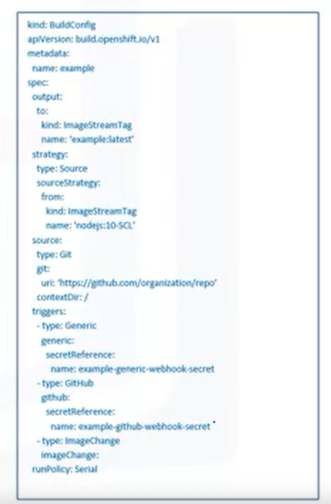

* *The triggers describe events that can automatically cause a build to run. While you can run builds manually in OpenShift, this process can and should be automated.*

***Build Triggers:***

* *There are three build triggers available that stipulate when a build should run. The first is Webhook triggers.*
* *A webhook sends a request to an OpenShift Container Platform API endpoint. Often, this will be a GitHub webhook, though it can also be a generic webhook.*
* *If a Github webhook is utilized, Github can send the request to OpenShift where there is a new commit on a certain branch, when a pull request is merged and under many more circumstances.*
* *Webhooks are great way to automate development flows so that builds can occur automatically as new code is developed.*
* *The second trigger is image change. In this scenario, builds can be triggered when a new version of an image is available.*
* *For example, if your application is built using a Node.js base image, that image will be updated as security fixes are released and other updates occur.*
* *You can automate a build to rebuild your containerized applications when base images are updated so that your code always contains the latest security fixes.*
* *Lastly, the configuration change trigger causes a new build to run when a new BuildConfig resource is created.*
* *We mentioned that the output for our example build would result in an ImageStreamTag.*
* *ImageStreams are a nifty way to represent images in OpenShift.*
* *An ImageStream is an abstraction for referencing images within OpenShift.*
* *Let’s say you store your images in IBM Cloud Container Registry and you push an image to your repo using the tag “latest”.*
* *You can push another image to that repo and use the “latest” tag again which will remove it from your first image.*
* *If your deployments were referring to images by repo and tag they would now start pulling the new image but that would be unintended.*
* *Each image also contains an ID, or digest, that identifies it. While tags can change the digest will not.*
* *ImageStreams do not contain image data but are pointers to image digests. Therefore, even if a new image is pushed with the same tag, Deployments referencing the ImageStream will not be changed until the ImageStream is updated to point to the new image.*
* *The source images that ImageStreams point to can be stored in the internal registry, external registries or other ImageStreams.*

***Operators:***

* *Operators are a powerful pattern used within Kubernetes to automate many tasks within a cluster and RedHat OpenShift provides a great way to easily install and use them.*
* *In addition to built-in resources like Deployments and Pods, additional resources can be created to extend the Kubernetes API.*
* *These additional resources are called custom resources, also known as custom resource definitions or CRDs.*
* *Ultimately, a custom resource is simply a new endpoint in the Kubernetes API that stores a collection of API objects.*
* *CRDs can be installed in clusters as operators choose. A CRD that one person creates is not available in someone else’s cluster unless that person chooses to install the CRD as well.*
* *Once the CRD is installed, its objects can be accessed using kubectl, as you would for resources like Pods.*
* *On their own, custom resources aren’t overly useful- they let you store and retrieve data in the Kubernetes API, but they don’t change the actual state of the cluster.*
* *To change the state, you need custom controllers. Recall that controllers are control loops that run in Kubernetes and monitor the actual state of the cluster, reconciling it with desired state as needed.*
* *Custom Controllers interpret the custom resource data stored in the API as a desired state and as with all controllers, work to maintain that state.*
* *Combining custom resources and custom controllers gives a true declarative API like Pods possess.*
* *The combination of these two concepts has come to be known as the “Operator Pattern”.*
* *An Operator is a way to package, deploy and manage a kubernetes native application which is an application that is deployed on and managed by Kubernetes.*
* *Human Operators have deep knowledge of the systems they oversee.*
* *They know how to deploy services, how those services should behave, and what to do if something goes wrong.*
* *Software operators attempt to capture and automate this knowledge in software that can be deployed to a cluster.*
* *Operators are thus a way to package whole applications or automate their tasks.*
* *Because of Kubernetes declarative API, operators provide the means to package and deploy whole applications and ensure that all the relevant components are present in the environment.*

***Examples:***

* *Deploying an application provides a great example of the usefulness of operators.*
* *As we have already seen, applications consists of more than just a single deployment.*
* *There can be Secrets, ConfigMaps storage resources and so much more.*
* *An operator can deploy the entire application in a simple manner.*
* *Another example is automating rote tasks in a cluster, like taking and restoring backups of an application’s state.*
* *This process can also be accomplished conveniently with an operator. If you want to deploy a whole application you could first create a custom resource for the application.*
* *You would also need to deploy a controller for that CRD.*
* *The core of the process is the operator logic, which needs to determine how to reconcile the actual and desired states.*
* *So if an instance of the CRD is declared, which Kubernetes objects(whether native objects or other CRD’s need to be created?*
* *In the OpenShift Container Platform web console there is a view called OperatorHub.*
* *This view makes available to the user a whole host of operators that can be installed with a simple click of the mouse.*
* *First are Red Hat operators, which are products packaged and shipped by RedHat.*
* *There are also certified operators from independent software vendors that RedHat has partnered with.*
* *Next are community operators that are available from the open source community but which are not officially supported by Red Hat on OpenShift.*
* *Finally, you will find custom operators defined by users. This wide variety of useful operators includes many tools from the Kubernetes ecosystem.*

***Microservice:***

* *A microservice architecture is a cornerstone of cloud-native development.*
* *There are cloud-native architectural approach in which a single application is composed of many loosely coupled and independently deployable smaller components or services.*
* *Microservices have well-defined APIs for communicating with each other.*
* *There are many benefits to microservices. They make it easier to update code because only the relevant service needs to be updated, not the entire application.*
* *They allow teams that develop different components of an application to use different technology stacks as needed for each component.*
* *When the application is running, components that experience more load can be scaled independently preventing the entire application from needing to be scaled when only one component requires more resources.*
* *For all their benefits, microservices come with challenges. When microservices communicate with each other, they need that communication to be secure so the traffic should be encrypted.*
* *Development teams might want to roll out new features to a subset of users or compare two versions of a feature in their application to see which engages users the most.*
* *In these cases, teams need canary deployments and A/B testing, which expose different versions to a service to different users.*
* *The communication between microservices also leads to the possibility of cascading failures if one service is unreachable or particularly slow.*
* *Developers need retries and circuit breaking to prevent a failure in one microservice from cascading to others.*
* *A Service Mesh is a dedicated layer for making service-to-service communication secure and reliable.*
* *It provides traffic management to control the flow of traffic between services, security to encrypt traffic between services, and observability of service behavior so you can troubleshoot and optimize applications.*
* *Istio is a commonly used service mesh. Its platform independent but it is often used on Kubernetes. Istio meets all the criteria of our service mesh definition.*

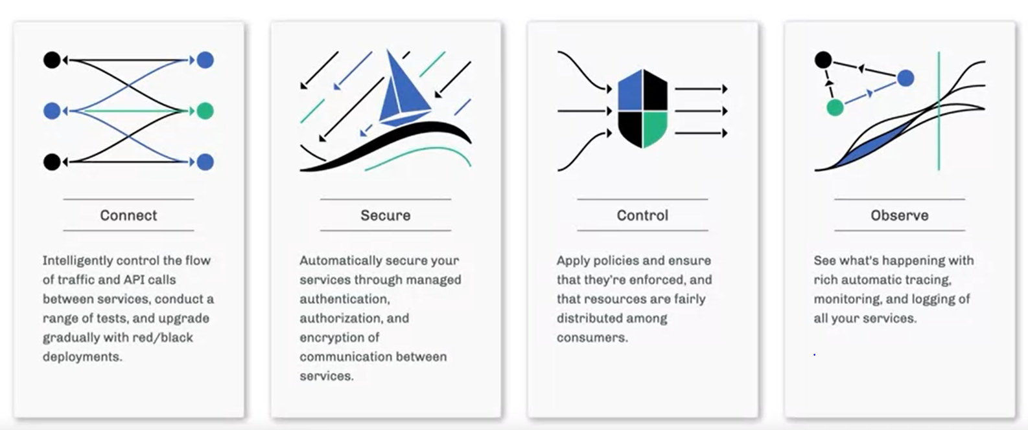

* *Connect or traffic management enables Istio to intelligently control the flow of traffic between services which in turn enables canary deployments, A/B tests and other deployment models.*
* *Istio secures services through authentication, authorization and encryption. Istio provides control be defining policies that can be enforced across an entire fleet.*
* *Finally, with Istio you can observe traffic flow in your mesh so you can trace call flows and dependencies and you can view metrics such as latency and errors.*
* *Consider this application architecture, The UI talks to an ordering microservice, which itself communicates with the inventory microservice which talks to a database.*
* *Service-to-service communication enables any microservices architecture, but as that communication gets more complex, a service mesh can help improve it.*

***Traffic Management:***

* *Istio can perform traffic shifting to gradually migrate traffic from one version of a microservice to another. So if the team that works on the ordering microservice has a new update to that microservice that can begin by sending 5% of traffic to the second version.*
* *Overtime, they can increase this to 50% and eventually to 100%. Similarly, Istio request routing enables you to perform A/B tests and send a subset of users to a certain version of a microservice while sending the remaining users to the original version.*
* *This can help ensure that a new version increases user engagement or performance, for example, Istio also provides a variety of security measures for your microservices.*
* *One example is encryption. In order to defend against man-in-the-middle attacks, its important for the traffic between your microservices to be encrypted.*
* *With Istio, traffic between services can be encrypted to ensure that its safe in transit.*
* *In addition, its easy to implement policies for service access control, so that a service is only able to talk to other services with which it is required to talk.*

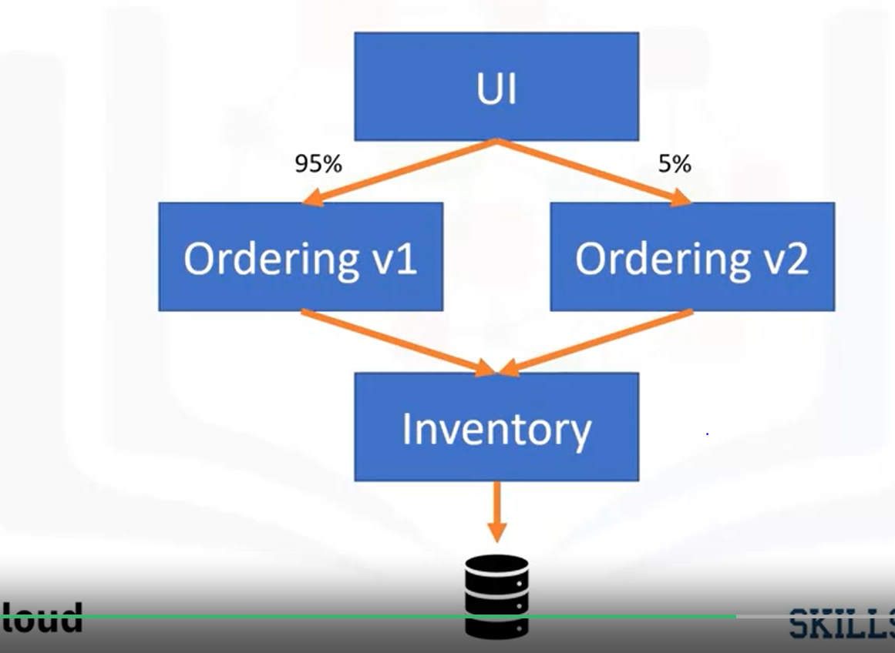

* *In the example, the UI service would be unable to communicate with the inventory service.*
* *Istio provides a number of metrics including service communication.*
* *These metrics cover the four basic service monitoring needs: latency, traffic, errors and saturation.*
* *For example, Istio provides metrics on request count, so that you can see how much traffic your requests are getting, and request duration, so that you can find bottlenecks and ensure that responses are given in a timely manner.*

***HandsOn:***

* *Open a new terminal*
* *Verify that oc CLI is installed. Command: oc version. You should see output similar to this  
  Client Version: 4.5.0-202002280431-79259a8*

*Kubernetes Version: v1.16.2+45a4ac4*

* *Change to your project folder. Command: cd /home/project*
* *Clone the git repository that contains the artifacts . Command: [ ! -d 'CC201' ] && git clone* [*https://github.com/ibm-developer-skills-network/CC201.git*](https://github.com/ibm-developer-skills-network/CC201.git)

***Use the oc CLI:***

* *OpenShift projects are Kubernetes namespaces with additional administrative functions. Therefore, projects also provide isolation within an OpenShift cluster. OC comes with a copy of kubectl commands can run with oc.*
* *List the pods in this namespace – Command: oc get pods You will likely see a few pods that are part of the environment.*
* *In addition to Kubernetes objects, you can get OpenShift specific objects. Command: oc get buildconfigs. Because you haven’t created a BuildConfig yet, this will not return any resources.*
* *View the OpenShift project that is in use. Command: oc project*
* *This project is specific to you and provides isolation within the cluster so that you can deploy your own applications.*

***Use the OpenShift Web Console:***

* *Open the OpenShift Web Console. The console should open to the project details for the project you have assigned. Click through the dashboard, overview and other tabs for this project. You should see inventory on the resources that currently exist in the project, the YAML that defines in the project.*
* *Notice the word “Administrator” at the top left. This indicates that you are in the Adminstrator perspective. Each perspective provides workflows specific to that persona. Switch to the Developer perspective to begin deploying an application.*

***Deploy an application in the web console:***

* *The developer perspective provides workflows specific to developer use cases, such as the ability to create and deploy applications. You are likely in the “Topology” view which provides a visual representation of applications.*
* *Click the +Add button to add a new application to this project.*
* *There are several ways to add a new application in OpenShift. Choose the From Catalog option.*
* *Search for “node” and click the Node.js tile. Click Create Application in the window that pops up.*
* *You should now be on a screen to create a source-to-image application. Recall that this means OpenShift will deploy an application using only one input from you: the application source. Beneath the****Git Repo URL****box, click****Try Sample****. This will populate the field with the URL of a sample application.*
* *Keep the rest of the default options and click****Create****.*
* *In the Topology view, you should now see your newly created application.*
* *View application in the web console*
* *The Topology view provides quick links to a lot of important parts of an application. You can:*
* *Click the outer circle to get information on the application.*
* *Click the inner circle with the Node.js logo to get information on the Deployment.*
* *Click the GitHub icon to access the code repository.*
* *Click the check mark to view the most recent build (you will see circular arrows if the build is in progress).*
* *Click the arrow coming out of a box to view the application in the browser if the application is externally available.*
* *Let's try some specific steps:*
* *Click the inner circle with the Node.js logo to bring up information on the Deployment.*
* *Observe the four resources associated with this Deployment: a Pod that runs the containerized application; a Build that uses the s2i strategy to build the application into a container image; a Service that exposes the application as a network service; and a Route that provides an externally reachable hostname.*
* *Click****View logs****on the line that says****Build #1****.*
* *Read the logs to see a few key completed steps. The repository is cloned, a Dockerfile is generated, an image is built, and the image is pushed to the internal registry.*
* *Click the****Overview****tab for this Build.*
* *Click the link to the owning BuildConfig under****Owner****.*
* *If you look at the****Overview****and****YAML****tabs, you'll see many concepts that we talked about in this module: triggers, build strategy, webhooks, and more.*
* *From the****Overview****tab, click the link to the ImageStreamTag under****Output To****.*
* *You can now see the ImageStreamTag that was created as an output of the build. Click the****History****tab to see the image in the internal registry to which this ImageStreamTag points.*
* *Return to the Topology view and click on your Deployment info. Click the Route that OpenShift automatically created for you. This will open the application in the browser.*
* *Wow! OpenShift did some pretty incredible work on your behalf. All it needed was a code repository and it was able to build the code into a container image, push that image to a registry, create a Deployment that references that image, and also expose the application to the internet with a hostname.*

***Final Handson: Project- GuestBook Application:***

* *Guestbook is a simple, multi-tier web application that we will build and deploy with Docker and Kubernetes. The application consists of a web front end, a Redis master for storage, a replicated set of Redis slaves, and an analyzer that will analyze the tone of the comments left in the guestbook. For all of these we will create Kubernetes Deployments, Pods, and Services.*
* *There are two versions of this application. Version 1 (in the v1 directory) is the simple application itself, while version 2 (in the v2 directory) extends the application by adding additional features that leverage the Watson Tone Analyzer service.*
* *We will deploy and manage this entire application on OpenShift.*
* *Open a new terminal Terminal -> New Terminal*
* *Change to your project folder -> cd /home/project*
* *Clone the git repository that contains the artifacts. git clone* [*https://github.com/ajp-io/guestbook.git*](https://github.com/ajp-io/guestbook.git)
* *Change the directory- cd guestbook*
* *List the contents – ls*

***Build the guestbook app:***

* *Change to the v1/guestbook directory. Command: cd v1/guestbook*
* *Run the following command or open the dockerfile in the Explorer. The path to this file is guestbook/v1/guestbook/Dockerfile. This dockerfile incorporates a more advanced strategy called multi-stage builds. Command: cat Dockerfile*
* *Export your namespace as an environment variable – Command: export MY_NAMESPACE=sn-labs-$USERNAME*
* *Build the guestbook app. Command: docker build . -t us.icr.io/$MY_NAMESPACE/guestbook:v1*
* *Push the image to IBM cloud container registry docker push us.icr.io/$MY_NAMESPACE/guestbook:v1*
* *Verify the image was pushed successfully. ibmcloud cr images*